Jo Ann Bingham Clinical Simulation Center

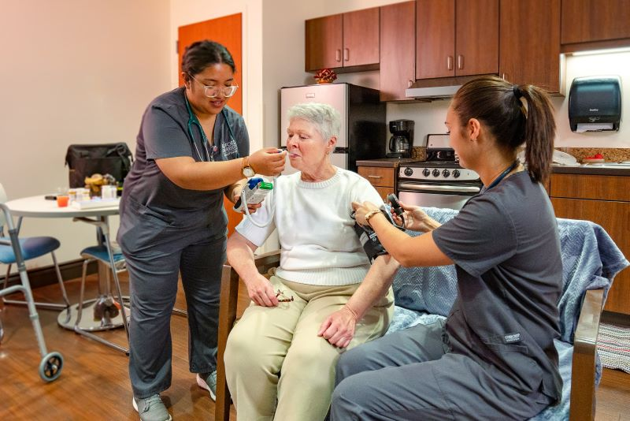

2024 Policy & Procedure Manual

TABLE OF CONTENTS
Contents
Scheduling 4
Resource Allocation and Scheduling Policy 4
Qualified Faculty 7
Scenario Development & Review Policy 8
Professional Conduct 13
Psychological Safety Policy 13
Confidentiality & Consent to Video Recording 15
Student Conduct Policy 16
Physical Safety 18
Labeling of Medications Policy 19
Labeling of Clinical Equipment Policy 20
Defibrillator Use Policy 20
Data Security 21
Data Retention Policy 21
Operations 22
Storage and Maintenance of Equipment 22
Concern or Complaint Resolution Policy 24
Center Utilization Reporting 27
Radford University Policies and Procedures 29

Simulation Policies and Procedures

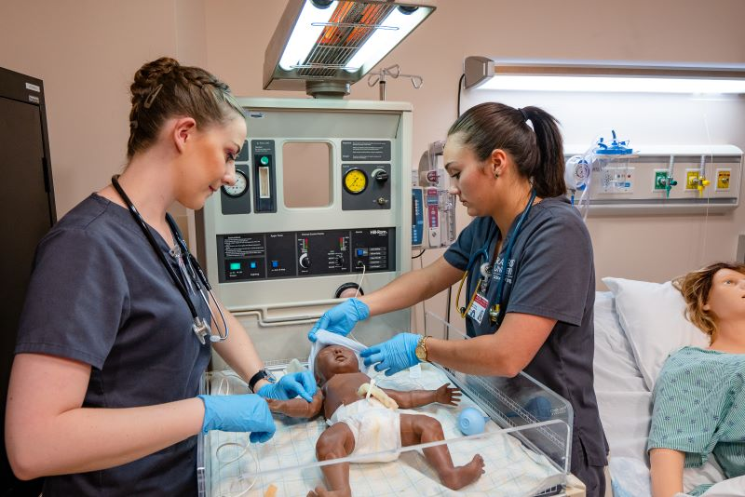

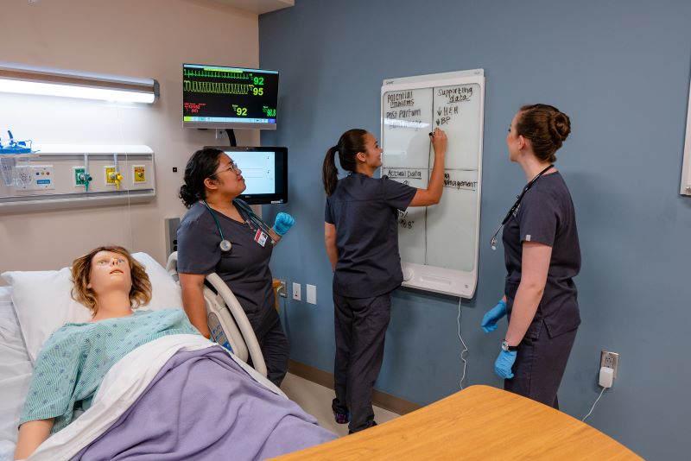

- Excellence

- Innovation

- Collaboration

- Discovery

- Sustainability

CORE VALUES

Scheduling
- Process: All requests for simulation must be entered on the clinical simulation center website by selecting “Request for Simulation Services” and completing the online request form.
https://www1.radford.edu/content/nursing/home/simlab.html
- Cancellation: Contact center administrative staff for any cancellations or schedule changes at least 24 hours in advance.
- See website for most current inclement weather policy.
- See Resource Allocation & Scheduling Policy.
- All education requests must be reviewed and approved by the JBCSC Director to ensure alignment with the mission of the simulation program.
- The center must be notified of any tours, visitors, or other non-educational activities ahead of time by contacting administrative staff. Unaccompanied, unscheduled visits are not permitted.
Contact Information
Radford Main Campus – Cook Hall
Lisa Young, Program Administrative Specialist
lfyoung@radford.edu
540-831-7175
Roanoke Higher Education Center
Roy Baugher Administrative Office Services Specialist III
rbaugher@radford.edu
540-831-1786

Resource Allocation and Scheduling Policy

- Purpose: To establish a procedure for scheduling and allocation JBCSC resources. Considerable resources go into the planning and implementation of simulation education activities. Those requesting to use the Jo Ann Bingham Clinical Simulation Center (JBCSC) personnel, equipment, and/or space for scenarios, programs, and courses must follow this established procedure to schedule appropriate resources. All educational activities delivered or conducted by the JBCSC will align with the JBCSC strategic plan.

- Definitions:
- Jo Ann Bingham Clinical Simulation Center (JBCSC): includes activities at the Roanoke Higher Education Center site and the Radford Cook Hall site.
- JBCSC equipment: includes simulators, task/procedure trainers, supplies, AV recording equipment, and other pieces acquired and maintained by the JBCSC
- Partnering Schools of Radford University College of Nursing: New River Community College, Patrick Henry Community College.

- Procedure:
  - All simulation requests should be entered in the Request for Simulation Services link on the JBCSC web page. Course faculty: this request form serves as the needs assessment. Include program and course objectives and select a simulation scenario that corresponds to the level of the learner and aligns with course objectives.
  - JBCSC resource allocations are prioritized in the following order:
    - College of Nursing students, partnering schools, and interprofessional education activities
    - Revenue generating activities
    - Single profession (Non-nursing) activities
    - External requests
  - Orientation Expectation: All learners must be oriented to the JBCSC prior to participating in clinical scenarios. A site and equipment specific orientation will be provided during the fundamental training session and/or pre-briefing as needed to prepare learner for simulation experience.
  - Hospital-based, acute care available time slots for scenarios are 3 hours in duration and scheduled Monday through Friday.
      - A.M. session [3 hrs, 2 patient scenarios]
      - P.M. session [3 hrs, 2 patient scenarios]
      - Flexibility in session times may be negotiated with the JBCSC educator if necessary to accommodate learner schedules and interprofessional education (IPE) sessions.

  - Hospital-based simulation activity scheduling:
    - JBCSC program director and simulation educators will remind faculty to enter requests in April for the fall and summer semesters and in November for the spring semester to assign dates and times for JBCSC experiences for the subsequent semester.
    - The JBCSC prioritizes session availability as follows:
      - Number of students in the course and activity design to determine number of sessions needed to accommodate request.
      - Number of educators needed to accommodate request.
      - Type of room/simulator needed for scenario request.
      - If two or more programs request the same date/time. Every reasonable effort will be made on the part of the JBCSC to accommodate each request.
      - Simulation educators/co-coordinators will work together between sites to determine if sessions can be granted at either site.
      - If the scheduling conflict cannot be corrected, the co-coordinator will notify the JBCSC Director who will have final responsibility for resolving the conflict taking into consideration: faculty resources, number of learners, standardized patient resources, equipment availability and use of supplies as appropriate to the requested simulation education modality.
      - If the JBCSC is unable to meet all requests, the CSC Director will consult with the College of Nursing Administrative Leadership Team.
    - The faculty requesting simulation sessions will provide individual learner names per scheduled JBCSC session to the JBCSC educator at least one week prior to the first scheduled session for that cohort.
    - The JBCSC educator will send admission tickets to course faculty.
    - The course faculty requesting simulation sessions are responsible for sending admission ticket documents to learners at least one week prior to scheduled JBCSC time.
    - JBCSC educator will place session times on Outlook calendar including scenario names, faculty contact information, school name, the course and course number, DocuCare patient name, # of students, student names, and note which educator plans to teach that session. The school, course name and scenario names should be in the subject and location lines of Outlook. All other information is entered within the appointment.
    - JBCSC educators are responsible for entering student names and keeping Outlook appointments current, as well as notifying administrative staff of any changes.
    - JBCSC administrative staff will schedule sessions in simulation management system (SIMIQ) and make DocuCare assignments.
    - JBCSC educators are ultimately responsible for tracking # of students per session (Board of Nursing requirement to track student clinical hours). If a student is sent home or does not show, the JBCSC educator is responsible for notifying course faculty the same day via email. The email serves as documentation of notification.

  - Procedure for use of Standardized Patient in manikin simulation sessions: available internally for JBCSC employees on shared drive – “Procedure for Standardized Patient Scheduling”

  - Standardized patient session clinic/apartment scheduling completed by JBCSC administrative staff:
    - Mental health: scheduled 1.5 hours. 1 hour at JBCSC + 30 minute debrief with course faculty on campus. [prebrief, simulation 30 min, SP feedback 30 minutes, 30-minute guided reflection and course faculty debrief]
    - Geriatric home health: Gero unfolding case (called “combo”) scheduled for 3-hour session in A.M. or P.M. Gero 3 (hospice visit) scheduled for 1.5 hours on site session.
    - The JBCSC administrative staff in collaboration with course faculty requesting sessions will coordinate scheduling of SP sessions in regards to SP availability, learner availability, and available rooms.
    - In the event that all sessions cannot be scheduled, the JBCSC administrative staff will notify the JBCSC Director.
    - The JBCSC Director will take into consideration number of learners, SP availability and space capacity to determine resolution.
    - If the JBCSC is unable to meet all requests, the CSC Director will consult with the College of Nursing Administrative Leadership Team If resolution is not possible, the JBCSC director will be responsible for notifying the course faculty requesting the simulation activity of sessions that cannot be honored.
    - Procedure for use of Standardized Patients in manikin simulation sessions: available internally for JBCSC employees on shared drive – “Procedure for Standardized Patient Scheduling”

  - Specifications for sending learners home without completion of simulation training experience:
    - Learners will be sent home if they arrive late. The JBCSC educator (acute care scenarios) or administrative staff (Gero or mental health) will notify course faculty that learner did not arrive on time to participate.
    - Learners without completed admission ticket(s) in hand (printed copy) will not be allowed to participate in simulation. The JBCSC educator (acute care scenarios) or administrative staff (Gero or mental health) will notify course faculty that learner did not arrive prepared to participate.
    - Rescheduling learners for training sessions due to tardiness and unpreparedness will be limited and not guaranteed. Course faculty will negotiate rescheduling with JBCSC educator or staff dependent on scheduling time availability.
    - Consistent enforcement of these procedures is expected.

Qualified Faculty
The term “qualified faculty” is used by the Virginia Board of Nursing in regulation 18VAC90-27-100. Curriculum for direct client care. D. Simulation for direct client care hours. To meet regulatory requirements and best practice standards, a qualified faculty member to facilitate simulation for direct client care hours at the JBCSC is defined as:
- Healthcare educator who provides documentation of completion of a minimum of 2.0 CEs in simulation debriefing.
- College of nursing (CON) faculty: a free CE debriefing module is available on D2L Learning Management System that meets this requirement.
- Healthcare educator must meet with JBCSC Director to jointly formulate an individualized professional development and evaluation plan. All simulation activities do not meet direct client care hour requirements.
- CON faculty may then earn the title and recognition of “Sim Super User” with 2 years of simulation experience at the simulation center. CON faculty may pursue the title of “Sim Champion” after 2 years of simulation experience and passing the Certified Healthcare Simulation Educator (CHSE) examination.

Scenario Development & Review Policy
- Purpose: To produce, test, and validate objective clinical scenarios that are based on best practice standards in clinical practice, simulation, and education and learner and faculty need.
II. Scenario Development Procedure (manikin-based):
- Content expert and certified simulation educator must collaborate to ensure the Healthcare Simulation Standards of Best Practice: Simulation Design are followed.
  - Prelicensure: The NLN Simulation Design Template must be completed by the author of the scenario after the simulation request has been approved by the simulation center Director. https://www.nln.org/education/education/sirc/sirc/sirc-resources/sirc-tools-and-tips (revised Feb 2023 version)
  - Post-licensure: Complete National Organization of Nurse Practitioner Faculties (NONPF) simulation design template available upon request from the JBCSC Director.
  - Schedule meeting with Director for review and next steps to ensure the Healthcare Simulation Standards of Best Practice: Simulation Design are followed.
- Develop objective scenarios driven by student events.
- Programming:
  - Student events create a manikin action (i.e., medication administration, O2 application, time too long).
  - Student events that do not elicit a manikin action (i.e., vital signs, lung auscultation, introduce self) are included in the menu.
  - Trends will be used whenever possible to simulate physiological changes in the manikin.
- Scenarios will develop and change over time during testing and validation processes. Scenarios must be reviewed annually by simulation and content experts.
  - JBCSC Director will schedule a pilot test of the scenario
  - Suggested revisions will be discussed with the scenario author
  - Scenario software are stored on the simulation center share drive following data protection policies
  - Scenario files are reviewed at least annually and updated as needed. The revised copy will be saved under the current year in the ‘Final Sim’ folder and the older file in ‘Archived’

III. Scenario Development Procedure (Standardized patient – SP based):

In addition to the Healthcare Simulation Standards of Best Practice (HSSOBP), the Association of Standardized Patient Educators (ASPE) Standards of Best Practice are also incorporated in the simulation design process
Background: Standardized Patient (SP) simulation includes the use of live actors to
serve in the role of patients and/or family members and is one type of simulation based
educational modality. The term Standardized Participant encompasses the use of live actors to portray roles other than patients including but not limited to: family members, other healthcare staff, etc. The simulation center uses the terms “SP” and “Standardized Patient” most commonly; but “SP” may indicate a role other than the patient. Because live actors are integrated into the
simulation environment, special considerations must be included in scenario development.
Simulation scenarios designed with SPs incorporate the ASPE domains: safe work environment, case development, SP training, program management, and professional development.

Definitions: To align with the simulation center’s web-based simulation management system terminology, we try to match use the following terms to avoid confusion:
Case = simulation with SP
Scenario = simulation with manikin
SPs may also participate in manikin-based scenarios. In that case, the term scenario is used.

References:

ASPE Standards of Best Practice
https://www.aspeducators.org/standards-of-best-practice

Healthcare Simulation Standards of Best Practice: Simulation Design
https://www.inacsl.org/healthcare-simulation-standards-ql

Society for Simulation in Healthcare Code of Ethics
https://www.ssih.org/SSH-Resources/Code-of-Ethics
Integrity
Transparency
Mutual Respect
Professionalism
Accountability
Results Orientation

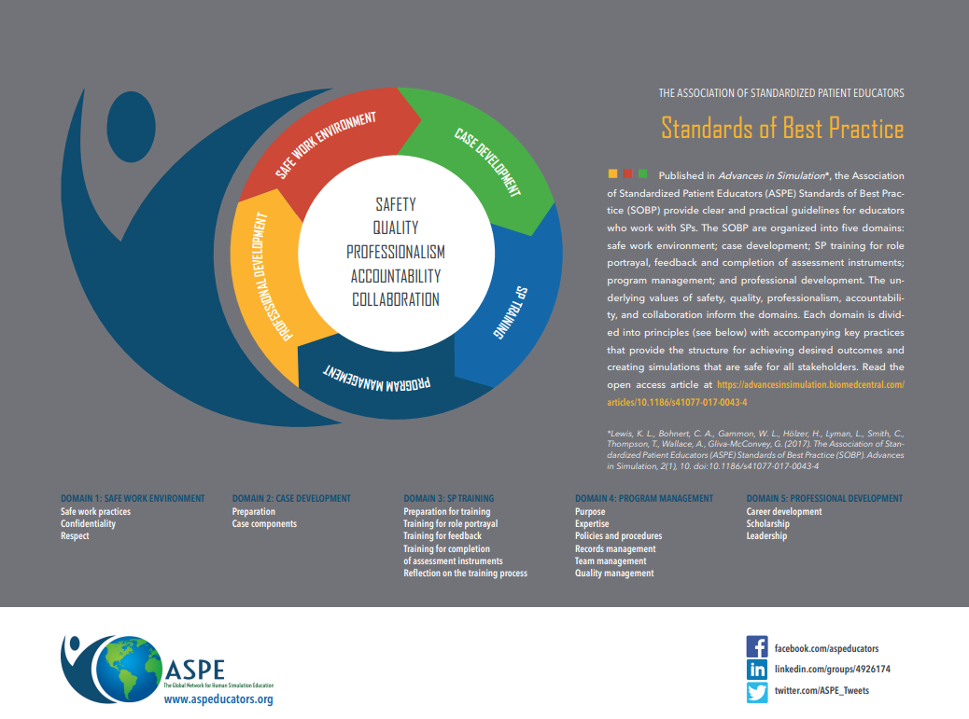
Domain 1: Safe Work Environment (Safe work practices, Confidentiality, and Respect)
1. SPs are given a break room area at each center site to isolate from learners prior to event, during breaks, and after conclusion of simulation event
2. SPs have a private dressing area (bathroom: individual stalls at each site)
3. Blinds drawn in rooms and clear signs posted on doors to protect against unnecessary observers. To safeguard against any unscheduled video/digital recordings of examinations, coverings placed over cameras
4. Safe, wearable technology prevents against accidental needlesticks. No biohazardous materials used during simulation. SPs are given the opportunity to debrief with
faculty instructor, event coordinator, or program staff following event to
address any issues or concerns that arose during the session with participants, equipment, etc.
5. SPs are provided training on any equipment used
6. SPs are highly valued and treated with respect as they are part of the educational team
Domain 2: Case Development
1. Case materials align with the learning objectives/goals of the simulation
2. A content expert creates the cases in collaboration with a simulationist to accurately reflect authentic patients and situations to avoid bias and stereotypes
3. Adequate time is allotted to draft and practice the case prior to the simulation event
4. An appropriate assessment tool is paired with the case
5. Each case contains accurate and sufficient details (i.e., medical history family history, social
history, medications, etc.).
6. Ideally, a practice pilot session is completed on new cases or to refresh older cases. If the pilot is the first live learner session, learners should be advised of expectations in prebriefing
7. SPs are provided with case/scenario specific practice trainings
8. Video examples are used when available
Domain 3: SP Training
1. Basic SP training would include: role portrayal, how to provide appropriate feedback to participants, and instruction on assessment tools.
a. In-person group trainings are ideal, allowing robust discussion and practice; video examples are useful for basic instruction and demonstrations, and are often more economical
b. It is the procedure of the simulation center to train all SPs in a mental health 1:1 (1 SP : 1 learner) case when hired. Each SP completes an ASPE video training module on feedback and follows a 10-step training process for those cases. Upon completion of at least 1-2 of those 1:1 cases, SPs then branch out to train on other cases or scenarios

Domain 4: Program Management
1. The program manager currently serves as the liaison to the Standardized Patients. The program manager is first assistant to the Executive Director of simulation to help recruit, hire, coordinate training, and organize documents for the SP program.
2. SPs are assigned a base location, either Radford or Roanoke simulation center site. An SP liaison for each site is currently being piloted to improve communication and organization of the program
3.SPs are provided a handbook containing best practices and procedures
4. Any fees associated with SP use in the program aligns with the program’s fee agreement and allocation of resources policy
5. Safety and integrity of teaching/testing materials is assured through annual content expert and simulationist review
6. Final approval of SP use in simulation is under the authority of the Executive Director. The Executive Director is responsible for reporting budget and staffing updates to the College of Nursing Executive Leadership Team and seeking assistance with oversight and guidance as needed.
7. Executive Director ensures New Case with SP checklist completed and saved on program’s shared drive

Domain 5: Professional Development
1. The program offers opportunity for SP development by sharing feedback with SPs from course faculty and from learner surveys

Checklist Template for Case Author

Case or Scenario Name:
Faculty content expert:
Simulationist:
Training dates
☐Initial case review by Executive Director of simulation:
☐Case complete and approved for scheduling:
☐SP case review with content expert:
☐Pilot/rehearsal:

Domain | Supporting Comments
1: Safe Work Environment
☐Safe work practices
☐Confidentiality
☐Respect
2: Case Development
☐Preparation
☐Case components

3: SP Training
☐Preparation for training
☐Training for role portrayal
☐Training for feedback
☐Training for completion of assessment instruments
☐Reflection on the training process
4: Program Management
☐Purpose
☐Expertise
☐Policies & procedures
☐Records management
☐Team management
☐Quality management
5: Professional Development
*SPs and faculty
☐Professional development
☐Scholarship
☐Leadership

*Standardized Patients are trained at the Jo Ann Bingham Clinical Simulation Center through an evidence-based 10 step process cited in the Comprehensive Healthcare Simulation: Implementing Best Practices in Standardized Patient Methodology textbook. Gliva-McConvey et. al. (2020). ISBN 978-3-030-43825-8

Professional Conduct
The patients and scenarios at the Jo Ann Bingham Clinical Simulation Center are to be treated as real patients. All participants in simulation and/or other visitors are to treat the center as a live learning environment by keeping noise level to a minimum and eliminate disruption of learning and to respect the psychological safety of all simulation participants. All simulation center users are expected to help set-up and clean-up their workspaces and demonstrate stewardship by being respectful in caring for the resources afforded to the center to meet the mission of the program. A list of expectations to keep the center clean and organized is available at the center as a guide. A Core Value of Radford University and the simulation center is sustainability. All users are to recycle supplies when able to do so and follow manufacturer instructions for cleaning and maintaining all equipment after each use. Minimizing other expenses such as travel, standardized patient use, and equipment purchasing is also expected to be implemented with good stewardship.

Psychological Safety Policy

- Scope: This policy applies to all users of the Jo Ann Bingham Clinical Simulation Center.

- Purpose: Psychological safety can impact a participant’s ability to be mindful and actively engage in simulation and debriefing. Adherence to the following guidelines is expected to ensure the psychological safety of every participant in simulation.

- Procedure:
      - Each learner will receive an orientation to simulation prior to coming to the first simulation experience.
      - A pre-briefing will occur prior to each simulation experience and the simulation educator will review the following information:
Ground rules of simulation
    - Define mindfulness and ‘being present’
    - Define reflection
        - Read Basic Assumption
        - Read Fiction Contract
        - Remind of Confidentiality Policy
        - Safe Phrase “I need to step out and tie my shoes”
        - Brief re-orientation for learners to the room including where supplies can be found and how to utilize technology
        - Scenario timeframe
        - How to obtain additional support during scenario if needed
        - Reminder that mistakes are expected and the simulation experience fosters the development of critical thinking, not perfection
- Trained and qualified simulation educators, staff, and/or standardized patients facilitate the entire simulation experience to ensure the absence of disruptive behaviors.
- If simulation educator(s), staff member, or standardized patient notes a learner is in obvious or expressed emotional distress or using the safe phrase due to an event that occurred during the simulation experience, or a past real-life experience, the following procedure will be followed:

Simulation center staff or educator will escort the student to a private area and calmly speak with the student. If student requires additional assistance,
For Radford University students (Main Campus)
Student Counseling Services (SCS) provides free, confidential, mental health services for eligible students. Please contact the main campus office to schedule the first appointment through email scs@radford.edu , call 540-831-5226, or stop by the office in the lower level of Davis Hall. Office hours are Monday – Friday 8 a.m. – 5 p.m.
Other community resources and/or for more immediate assistance:
- Radford University Police Department: 540-831-5500
- ACCESS: 540-961-8400
- CONNECT: 540-731-7385
- National Suicide Hotline: dial 9-8-8
- Crisis Text Hotline: text 74174

Roanoke Higher Education Center location: Call 540-831-1691 for Student Counseling Services at Radford University at Carilion. Email: rucwellness@radford.edu. Office hours are Monday – Friday 8 a.m. – 5 p.m.
Other community resources and/or for more immediate assistance, contact:
- Blue Ridge Behavioral Healthcare
Mental Health Crisis Services
540-981-9351
- Carilion CONNECT
CONNECT is a confidential, 24-hour emergency evaluation and referral service provided by Carilion Clinic to members of our community. CONNECT is staffed by psychiatric nurses and clinical social workers trained to help people access psychiatric and behavioral medicine support. For support, call 540-981-8181 or toll-free 800-284-8898.
- RESPOND Lewis Gale
540-776-1100
The simulation center staff or educator will contact the student’s course lead faculty by phone to notify them of the incident as soon as possible.

For New River Community College (NRCC) students
Simulation center staff or educator will escort the student to a private area and calmly speak with the student. The student will be given the option to continue, leave for the day, or seek counseling services:
- New River Valley Community Services
    - Simulation staff or educator will call 540-961-8400 and request assistance to triage the student need and collaboratively determine the next, safest course of action for the student (24 hr crisis hotline)
    - The simulation staff or educator will contact the student’s program director and notify them of the incident as soon as possible, ideally before the student leaves the center

For Patrick Henry Community College (PHCC) students
Simulation center staff or educator will escort the student to a private area and calmly speak with the student. The student will be given the option to continue, leave for the day, or seek counseling services:
  - Timely MD from the link: TimelyMD | Patrick & Henry Community College (patrickhenry.edu) (24/7 mental health counseling for PHCC students)
  - OR call the Piedmont Community Board. Simulation staff or educator will call 888-819-1331 and request assistance to triage the student need and collaboratively determine the next, safest course of action for the student (24 hr crisis hotline)
  - The simulation staff or educator will contact the student’s program director and notify them of the incident as soon as possible, ideally before the student leaves the center

Confidentiality & Consent to Video Recording

Purpose:
To describe the confidentiality and video recording procedure for all participants in simulation activities.
Policy & Procedure: All participants in simulation must sign the Confidentiality & Consent to Video Recording Form or they will not be permitted to participate in simulation activities.

Confidentiality & Consent to Video Recording Form

- The Confidentiality and Video Recording Agreement and Consent is required to be completed by all participants in a simulation activity at the JBCSC.
- By signing this agreement, you agree to maintain strict confidentiality regarding both your and the other learners’ performance, whether seen in real time, on video or otherwise communicated to you. Patients at the JBCSC should be treated as real patients.
- All participants in a simulation activity, whether live or virtual platform, must sign the Confidentiality and Video Recording Agreement and Consent or they cannot participate in the simulation.
- Not all sessions will be videotaped, but if videotaping does occur it will be for educational, evaluation, and research purposes only. The only exception to this is if a participant signs a media release for the purpose of allowing a videotaping or pictures, for marketing or promotional purposes.
- The entire center should be treated as a public space. Cameras are program wide and could be actively recording or undergoing system checks. Private spaces without cameras include restrooms, offices, and designated break rooms.
- A breach of confidentiality may result in loss of privileges to the JBCSC.
- Recorded videos are stored on a secure server on-site with limited access by University IT and/or simulation technologists and are purged from the system within 2 years of student graduation.
- Videos requested for education or research purposes may be requested via email to the Executive Director of the JBCSC.

A pdf form with signature line is located on the center website for uploading to electronic systems or may be printed and signed on site. Copies of this form must be stored until student learner graduation. JBCSC administrative staff are responsible for storing forms on the center shared drive or ensuring they are signed and stored in another location such as the student’s home school. The location of the agreement should be documented and known in the event of the need to reference the signed form.

Student Conduct Policy
Scope: This policy applies to all student learners at the JBCSC
Purpose: To outline the expectations of student conduct at the JBCSC on the Learner Agreement Form.
Procedure: Student must sign the Learner Agreement Form or they will not be permitted to participate in simulation education activities. Students must also adhere to their university or college student conduct policies as well as the policy at the JBCSC while participating in simulation.
Learner Agreement Form
The JBCSC is designed to provide the learner with the opportunity to practice skills and problem solving in a simulated healthcare environment. The centers maintain the equipment and the resources to facilitate the learner’s acquisition of competence with the skills to care for patients in the clinical setting.
Learners in a professional nursing program must function within the legal, moral, and ethical standards of the profession. Therefore, each learner must adhere to the following guidelines for your clinical simulation preparation and performance. It is expected to maintain strict confidentiality regarding both your and other’s performance, whether seen in real time, on video or otherwise communicated to you.
- Attendance: Clinical simulation experiences are offered at specific times. Learners are expected to be on time. Late arrivals will not be allowed to participate in simulation and it will be a missed clinical experience.
- Dress code: The JBCSC adheres to your School or College of Nursing specific clinical site dress code. Failure to show up in clinical dress will result in not being allowed to participate and it will be a missed clinical experience.
- Required Equipment:
  - Mental Health Scenarios: Name badge
  - Hospital Scenarios: Name badge & Stethoscope, other items that fit into scrub pocket are permitted but not required such as pen light, bandage scissors, etc.

- Personal Items:
  - There is no secure area to store personal items. All personal items should be left at home, in car, or placed in unsecured lockers/cabinets during your time in the center.
  - You may use your cellphone if you need to reset your password to log into the simulation software system (single sign on and multifactor authentication). Otherwise, phones are not permitted for use as a student learner without permission from JBCSC staff or educators. If seen using your cellphone during instructional time without permission, you may be asked to leave which will count as missed clinical time.
- Prior to your arrival to the JBCSC:
  - Complete an Admission Ticket for EACH patient scenario. NOTE: Completed and printed admission tickets are required for participation in simulation experiences. Failure to have completed admission tickets in hand will result in not being allowed to participate and will be a missed clinical experience.
  - Prepare for your simulation session as you would for any clinical experience.
- Food and drink are not allowed in the center patient care areas, computer rooms, or simulation rooms except water with a secured lid. “Secure” means a lid that will not fall off or spill water if accidentally knocked over. Plan accordingly.
- Equipment and items (syringes, needles, simulated medications, patient chart documents, etc.) used during simulation are property of the JBCSC and cannot be removed or taken from the center.

A pdf form with signature line is located on the center website for uploading to electronic systems or may be printed and signed on site. Copies of this form must be stored until student learner graduation. JBCSC administrative staff are responsible for storing forms on the center shared drive or ensuring they are signed and stored in another location such as the student’s home school. The location of the agreement should be documented and known in the event of the need to reference the signed form.

Physical Safety
Any accidents or incidents occurring at the Jo Ann Bingham Clinical Simulation Center must be handled according to Radford University policies and procedures. The next section of this manual lists the university policies applicable to the simulation center with hyperlinks. Find simulation specific policies below.
- Purpose: To ensure physical safety of individuals involved in simulation.

- Procedure:

  - Simulation center users should follow universal precautions while participating in clinical activities. While practicing skills at the simulation center, learners should practice the same safety precautions followed in clinical settings.
  - Jo Ann Bingham Clinical Simulation Center (JBCSC) educators exercise their discretion in allowing students that present to the center with signs of infectious illnesses to participate in simulation activities.
  - Students are required to participate in an orientation to simulation, to review processes, equipment, and manikin safety
  - All sharps must be disposed of in an appropriately labeled sharps container. Under no circumstances may sharps or supplies be removed from the Center.
  - The simulation center follows University lab policies and is considered a dynamic lab environment https://www1.radford.edu/content/ehs/home/programs/Lab_Safety.html
  - Hand washing or use of hand sanitizers are part of practice in the Center.
  - All injuries or accidents must be reported to simulation center staff and/or educators who will follow the University guidelines for reporting to the Environmental Health & Safety department. It is reasonable for staff or educators to provide basic first aid such as washing a cut or applying a band-aid. For more serious accidents or injuries, follow the Safety Policy procedures and/or contact emergency personnel. Policy and procedure https://www1.radford.edu/content/ehs/home/safety-plan/safety-policy.html
  - Any damaged or potentially dangerous equipment should be removed from the simulation room and reported to the center educators or staff immediately. Simulation technologists will inspect equipment and notify JBCSC Director or Director of Operations of damage equipment to determine next course of action.
  - University fire safety guidelines are followed and inspections are performed by the EHS office fire safety inspector https://www1.radford.edu/content/ehs/home/programs/fire-life.html . The Roanoke Higher Education Center inspects and conducts safety drills for the Roanoke center location. Evacuation routes are posted clearly at each site. Exits are clearly marked and unobstructed.
  - Food and drinks are not allowed in the patient care areas. Water with secure lids are allowed in the debriefing rooms only.
  - Learners are expected to adhere to their respective school dress code policies to ensure safety while participating in simulation activities.
  - The simulation center educators make every effort possible to ensure a latex free environment. All gloves and medication administration equipment used during simulation activities are latex free. Notify the simulation educator if you have a latex allergy.
  - Learners are expected to utilize equipment such as defibrillators and code carts per JBCSC policy (See Safety: Defibrillator Use Policy)
  - Simulation Center staff may notify security of any suspicious or dangerous behavior. Radford Campus 540-831-5500 or Roanoke Higher Education Center Security 540-767-6001 or by calling 911 at either location.

Labeling of Medications Policy
Purpose: To ensure the appropriate separation and safe use of simulation and actual patient care supplies and medications found within the Jo Ann Bingham Clinical Simulation Center (JBCSC).
Procedure:
- Expired medical supplies that have not been opened are often donated for use in the JBCSC. After use of the expired supplies in simulation, they are discarded appropriately by the JBCSC to ensure they are not used for actual patient care.
- No real medications are to be used in the JBCSC. Medications used are purchased and labeled by the retailer as “for training use only” or “simulation use only” medications. Individual demo medications used in simulation, i.e. pills, tablets, capsules, are placed in small bags and labeled by the JBCSC staff or in demo labeled packaging as supplied by the retailer.
- All donated expired IV medications – bags or bottles, etc. are emptied of real medications and fluid. Empty containers are filled with distilled water to simulate real medication. Additions of non-toxic materials may be made to the containers to attain a more “realistic” appearance.
- IV tubing, vials, and IV bags are inspected regularly for any evidence of mold or bacterial growth and are cleaned or discarded.
- Medications or supplies that are not labeled and actively used during simulation are stored in stock closets behind locked doors and inaccessible to learners.
- No supplies or medications are to be removed from the JBCSC.
- All supplies and medications are secured within the JBCSC behind a locked entrance door during unattended and off hours. Learners or visitors are not permitted in the simulation center without a JBCSC staff member or educator present.

Labeling of Clinical Equipment Policy
- Purpose: To ensure the appropriate separation and safe use of simulation and actual patient care equipment found within the RU Jo Ann Bingham Clinical Simulation Center (JBCSC).

- Procedure:

- All clinical equipment used in simulation is for JBCSC use only. The JBCSC does not loan any equipment to facilities that provide actual patient care. All clinical equipment is labeled, “For Simulation Use Only” “For Training Use Only”.
- Equipment used during standardized patient sessions follows manufacturer’s recommendations. Equipment is adapted to be used safely with standardized patients (i.e. Oxygen tubing is adapted so that oxygen prongs are blocked so no air travels through the device). New supplies such as temperature probes are opened each time they are used on standardized patients.
- No equipment or supplies are to be removed from the JBCSC without approval from the JBCSC Director or Director of Operations.
- All equipment and supplies are secured within the JBCSC behind locked doors during off hours or when not in use.

Defibrillator Use Policy

- Purpose: The Jo Ann Bingham Clinical Simulation Center (JBCSC) strives to provide a safe learning environment at all times. The use of medical equipment including defibrillators in a simulated environment can present potential safety concerns that must be managed. The JBCSC acknowledges the importance of training with real clinical equipment and makes every effort possible to implement the most up to date equipment for JBCSC users.

- Procedure:

  - All JBCSC educators will observe and comply with routine practice regarding the use of defibrillators and code carts.
  - These devices are “Not for Patient Use”. The defibrillators and code carts are only approved for use in simulation and are not intended for patient or clinical use.
  - General use of defibrillators is reviewed with learners by JBCSC educators prior to use.
  - The Zoll defibrillator used by the center is a training model that grounds the shock, specifically for use in simulation.
  - Medications found within the Code Cart are simulated medications and labeled as such.
  - Learners are observed at all times during use by JBCSC educators who are prepared to intervene in the event of a safety concern.
  - Learners must demonstrate proper procedure of “clearing the patient” prior to delivering a simulated shock.

Data Security
The Jo Ann Bingham Clinical Simulation center adheres to Radford University Information Technology security policies and procedures located at https://www1.radford.edu/content/it-security/home.html Every employee at Radford University must complete mandatory annual SANS Security Awareness Training that covers procedures for securing all forms of data including databases, electronic records, paper forms such as evaluations, etc. See guidelines at https://www1.radford.edu/content/it-security/home/training/sans-training.html Below are data security policies specific to the clinical simulation environment.

Data Retention Policy
- Purpose
Radford University is committed to maintaining a reliable and secure technology infrastructure. Secure storage of media and sensitive data is critical to the security of University information. This policy provides guidelines for handling of sensitive data and protecting media from compromise.
Examples of electronic data collected include: survey data, video recordings, learner emails, username login to Education Management Solutions (EMS) AV system, SimIQ software program,

- Policy
Video, performance checklists, and other survey data storage records/media are physically secured in a server room behind locked door and logically secured using SimIQ simulation management software or stored on a whale drive (center shared drive) and secured by the university IT department. Access control provides multi-layered access for a variety of roles from participant student up to Administrator level. Within each role, access to data is limited by scope and/or by the time period during which access may be granted. Video files are purged from the system within 2 years of student graduation.

- Procedure:
- Single sign-on (SSO) with multi-factor authentication is used to access the SimIQ system. comply with best practices recommended by “Code of Practice for Information Security Management”.
- The simulation center pays an annual software agreement fee to EMS. EMS, Radford University IT, and simulation technologists all work collaboratively to secure data.
- Simulation technologists serve as media custodians and are responsible for protecting the video in their possession from unauthorized access, alteration, destruction, or usage.
- Video and any media containing highly sensitive data must be physically and logically secured.
- Backups are performed by Radford University IT including tape backups in a secured, locked location.
- Incremental backups are performed daily, and a full system backup is run weekly for all servers at both sites.
- Learner and participant email addresses, learner performance, and/or some survey data may be stored on the center shared drive. The whale drive is secured and monitored by university IT and access is restricted to full-time simulation center employees only.
- University IT is contact if recovery of data is ever necessary.
- The simulation center does not collect highly sensitive data defined at Radford University as: social security number, driver’s license number, passport number, federal ID number, credit card, debit, or financial account numbers.

RUIT security policy
https://www1.radford.edu/content/dam/departments/administrative/policies/InformationTechnologyPoliciesandProcedures/IT-PO-1503_InformationTechnologySecurityPolicy.pdf

Standards
https://www1.radford.edu/content/dam/departments/administrative/doit/documents/RU_IT_Security_Standard_10202022.pdf

Data Storage and Media Protection
https://www1.radford.edu/content/it-security/home/data-classification-and-storage.html

Operations

Storage and Maintenance of Equipment
- Purpose: To ensure equipment compliance with Radford University Policies and standards of operation, maintaining optimal equipment conditions for operations.

- Procedure:

- Warranties and/or service plans are included with simulator capital purchases whenever possible.
- For simulators and equipment beyond warranty, the center aims to send a JBCSC simulation technologist for training to perform preventive maintenance on-site. The simulation technologist is responsible for collaborating with vendors to ensure equipment is properly maintained. Simulation technologists are also responsible for teaching and training simulation educators, standardized patients, and staff how to perform daily simulator and computer maintenance to ensure best practices are followed. Simulation educators are ultimately responsible for the oversight of the simulation scenarios they facilitate and need to know proper maintenance procedures when simulation technologists are unavailable.
- Simulation educators and technologists are responsible to follow vendor specific Directions For Use (DFU) for cleaning after use to ensure maximum use of simulator lifespan to include but not limited to:
  - Cleaning reservoirs
  - Cleaning soiled manikins
  - Emptying fluid tanks as appropriate
  - Victoria simulator positioning: Position the simulator with legs bent at knees and/or head of bed elevated to prevent silicone skin from overstretching and tearing in manikin groin area.
- Information/Simulation Technology Specialists’ responsibilities:
  - Follow-up and resolution of equipment problems in a timely manner with attention given to issues affecting instruction.
  - JBCSC Simulation technologist will communicate to staff and/or educators the outcome of the problem and any process changes necessary to maintain operations.
  - Disposable parts (arm skins, injection pads etc.) will be replaced on an as needed basis.
  - Non-disposable parts will be repaired or troubleshooting performed by Simulation technologist according to vendors Directions for Use (DFU). If a part is not repairable it will be replaced in the shortest possible time to minimize interruption of JBCSC operations.
  - Preventive maintenance on simulators/simulation equipment will be conducted by JBCSC Simulation Technologists on a biannual basis during academic breaks (June & December) either independently or in conjunction with vendor during purchased Preventive Maintenance services.
  - Preventive maintenance will be conducted on all computers on a monthly basis to ensure compliance with Radford University Information Technology guidelines. This maintenance will include but not limited to:
    - Updating all systems (OS updates)
    - Hardware diagnostics, repair. and replacement
    - Servers are maintained by network administrators in the university IT department
- Simulation technology specialists, in collaboration with JBCSC director will analyze extended warranty criteria annually and determine which simulators need additional warranty purchases.
- The JBCSC will utilize the Equipment Trust Fund (ETF), one-time spending, and/or other funding sources to upgrade equipment, simulators, and purchase new equipment/technologies to support strategic plan initiatives. The JBCSC team will determine items to be requested and the JBCSC Director will initiate request through approval process.

- Laerdal Simulators Care:
- SimMan 3G and 3G+:
  - At least once a week to flush used tanks (Body fluids and/or blood) with distilled water until purged liquid is colorless. Then charge one or both tanks with 100 ml of 70% isopropyl solution and flush again. This way remaining liquid in the tanks and tubing is mainly alcohol which prevents molding and ensures mannequin’s liquids system’s functionality.
- SimMan Essential:
  - Flush urine tank with uncolored distilled water as described above for SimMan 3G until purged liquid is colorless. After that load tank with 100 ml of 70% isopropyl solution and purge all liquid one more time.
- SimMom and Nursing Anne:
  - Clean all surfaces with a mild detergent (Dawn preferred) and damp washcloth, then thoroughly. Manikins should not be immersed in water.
  - Wash/flush fluid bags/tanks with tap water
  - Fill with distilled water
- SimBaby, SimJunior, Nursing Kid:
  - Clean all surfaces with a mild detergent (Dawn preferred) and damp washcloth, then dry thoroughly. Manikins should not be immersed in water.
- How often to perform this care:
  - Clean/disinfect all surfaces after each use (manikins, bedrails, keyboards, computer surfaces) with approved cleaning product
  - Replace moulage as needed between scenarios

- GAUMARD Simulators Care:
- Victoria/Super Victoria (S2200):
  - Check for fluid accumulation at the bottom of pelvic area. Make sure entire area is dry. Maintain proper battery handling procedure.
  - Clean with a cloth dampened with diluted liquid dishwashing soap. If medical adhesives remain on the skin, clean with alcohol wipes.
- SuperTory (S2220) and Tory:
  - Maintain proper battery handling procedure.
  - Clean with a cloth dampened with diluted liquid dishwashing soap. If medical adhesives remain on the skin, clean with alcohol wipes

Concern or Complaint Resolution Policy
- Policy: Service Excellence is a high priority for Jo Ann Bingham Clinical Simulation Center (JBCSC). The goal is to resolve concerns/complaints in a timely manner to meet the simulation needs of our partnering organizations, faculty, staff, learners and the public. The JBCSC considers concerns/complaints initially as a concern. In the event the concern cannot be resolved when recognized and/or with basic professional communication, the concern will be escalated to the JBCSC Director. The JBCSC Director will determine if the concern requires documentation regarding a programmatic issue, an education activity issue, or a personnel performance issue. In the case of a programmatic issue, the Program considers the concern a complaint and will follow the Program Improvement Plan – Operations policy and procedure. Concerns re: educational activity will be discussed with the team of simulation educators to determine if changes are needed. Complaints re: personnel will be handled on an individual basis with the JBCSC Director who is also the work Supervisor of record.

- Procedure:

  - Inter-professional concern/complaint resolution with internal and external customers:
    - Concerns regarding scheduling services or resources:
      - For acute care, hospital based simulations:
        - Co-coordinators at each site are to attempt to meet scheduling needs taking into account space and simulation educator availability.
        - Co-coordinators will also take into account timing of request.
        - Co-coordinators will work together between sites to determine if sessions can be granted at a different site.
        - If the scheduling concern cannot be corrected, then co- coordinator will notify the JBCSC Director who will have final responsibility for resolving the concern.
      - For standardized patient (SP)based simulations:
        - Administrative specialist will attempt to meet scheduling needs taking into account space, standardized patient availability, and learner schedules.
        - If scheduling concern cannot be corrected, then administrative specialist will notify the JBCSC Director who will have final responsibility for resolving the concern.
      - When concerns are escalated to the JBCSC Director, they will take into consideration: Faculty resources, number of learners,

SP resources, equipment availability and use of supplies as appropriate to the requested simulation education modality.
    - Inter-professional concerns - JBCSC Faculty and Staff are expected to act in a professional manner with all simulation users and fellow faculty.
      - In the event that a concern occurs, the involved parties should make every effort to discuss and work out the concern through peer to peer professional communication.
      - In the event, that concern resolution is unsuccessful then the JBCSC Director will be notified and determine the course of action required to resolve the concern.

  - JBCSC employee concern resolution: Radford University has processes in place to handle employee grievances based on their employment category.
    - Faculty Educators/Co-coordinators: In the event that a complaint or concern arises, the employee is to follow the Radford University Administrative and Professional Faculty Grievance Procedure found in the Radford University Administrative and Professional Faculty Handbook at https://www1.radford.edu/content/dam/departments/administrative/ap-faculty-senate/AP%20Handbook_Revised_December2,2022.pdf
    - All other JBCSC employees: Administrative Specialists, Information Technology/Simulation Specialist or standardized patients: In the event that a complaint or concern arises, the employee is to follow the Workplace Dispute Resolution/General Grievance Provisions outline in the Grievance Procedure Manual found at https://www1.radford.edu/content/human-resources/home/employee-relations/relations.html

  - Learner Concerns:
    - Each learner will complete a post encounter survey and have the opportunity to provide feedback about the simulation, including any complaints or concerns that arise.
    - If in-person learner issue or concern arises; the JBCSC faculty or staff that received the concern will attempt to resolve the issue and/or notify the JBCSC Director depending on the scope of the issue. Once notified, the JBCSC Director will have final responsibility for resolving the concern.
    - Learners also have their School or College of Nursing procedure for non-grade related complaints or concerns.

  - Concerns may also be received through emails, letters, and/or session evaluations.
    - If a concern involves a JBCSC employee, the JBCSC Director will address the issue with them individually.
    - General concerns will be discussed during JBCSC faculty/staff meetings as needed.

Center Utilization Reporting
All simulation activities, both educational and non-educational, must be documented and saved on the simulation center shared drive in the “Reports” folder. JBCSC staff are responsible for documenting: date, session name or description of activity, # of participants and/or visitors & # hours at the center. Center utilization reports (Excel format) are run each semester and at the JBCSC Director’s request.

Radford University
Policies and Procedures

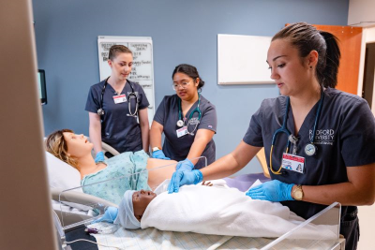

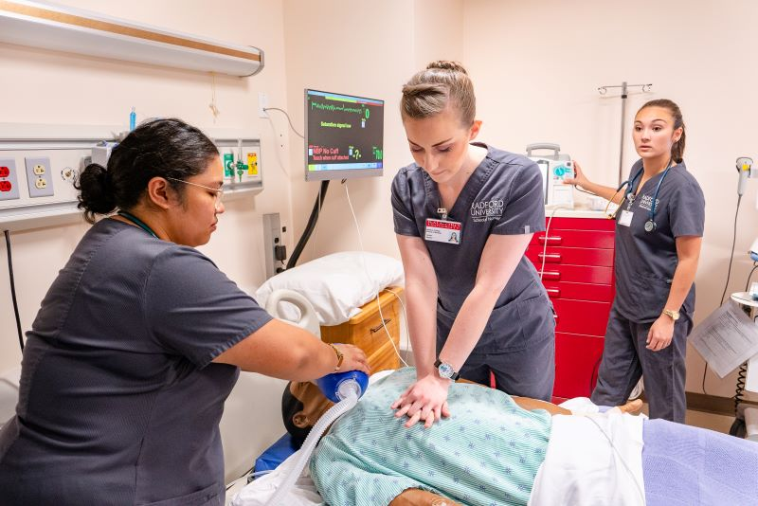

- Student Empowerment
and Success

- Excellence

- Inclusiveness

- Collaboration

- Community

- Intellectual Freedom

- Innovation

- Sustainability
CORE VALUES

Radford University Policies and Procedures

- Active Shooter, run, hide, fight
- Active shooter checklist
- Communicating with government officials
- Employee tuition waiver
- Evacuation
- Facilities access control
- Fee policy
- Food and beverage
- Fraud, waste, and abuse
- Free expression
- Funds handling
- Gifts acceptance
- Information technology accessibility
- Information technology infrastructure, architecture, and ongoing operations
- Information technology project management
- Information technology security
- Institutional base pay
- Internal audit
- Investment of employee benefits funds
- Investment management
- Main Campus emergency procedures
- Payment cards
- Physical inventory
- Posting, chalking and distribution of informational materials
- Post office box
- Procurement contracts
- Records management
- Reporting suspected child abuse or neglect
- Secure in place
- Span of control
- Standards of student conduct
- Substantive change
- Surplus property management
- Telework
- University policy management
- University travel
- Using university facilities

