Emma Tip Sheet
Getting Started
- You can log in using the Emma tile in OneCampus.
- Log in using your Radford username and password.
Note: You may get a pop-up asking for an Emma Verification Code. This is a security measure to ensure you are who you say you are and it will send an e-mail to you with a six-digit code to input in the pop-up box.
- Once logged in, you should be on the Emma home screen. You’ll see a calendar in the left-hand column, screenshots of the e-mails you’ve sent to the right and information about your overall mailings at the top of the screen.

Campaigns
Each e-mail you send is referred to as a “Campaign.” Here’s how to get started with an e-mail campaign:

- Click on the blue “Create New Campaign” button at the top right-hand side of your screen.
- A pop-up will appear with the title, “Create a new campaign.
- Name your e-mail campaign. This is just the campaign’s name in Emma, not the subject of your e-mail. You’ll input the subject later. This name allows you to find the e-mail later, so naming it clearly and identifiable is important. In addition, adding the date can be helpful.
Example of a campaign name: Radford University CONNECTED – 8-22-25

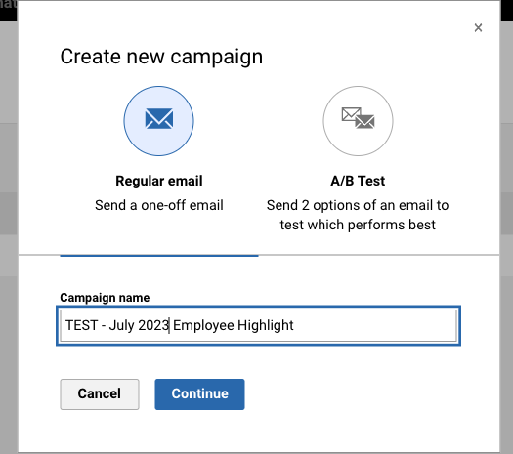

- Click continue.

Templates
- Click on “Shared templates” in the left-hand column.
- You should now be on the “Choose template” page where you can hover over your template of choice to the right.
- When you have chosen your template, click on the “Start here” button.

Editing Your E-mail
- Your template will load and you should now be on the editing screen.
- Several placeholders have been included in your template to help you get started. You can begin working in those by clicking on the areas where text is located.
- To add new content areas to your e-mail:
  - Start by locating the three tabs in the right-hand column titled Content, Rows and Settings.
  - To add new content, first click on Rows where you’ll see sets of blue boxes. The solid box is a complete row across the body of your e-mail, and the broken rows will divide up your content into those sizes. Click and drag the row layout of choice onto the e-mail body to the left. You will see a blue bar appear that reads, “Drag it here” in the spots where it can be placed. When it’s where you want it, unclick and it will appear as a blue box in the body of your e-mail.
  - Now, click on the Content tab. You will see tiles on that tab that say things like, Title, Paragraph, List, Image, etc. Here’s what each will do:
Title: add a bolded, larger font title or header to your e-mail
Paragraph: add text to your e-mail
List: add a bulleted list to your e-mail
Image: add a picture to your e-mail
Table: add a table to your e-mail
Divider: add a dividing line into your e-mail
Video: add a link to a video in your e-mail (this just adds a link to the video hosted elsewhere)
The rest we don’t use, so I would avoid using them.
  - You will click and drag the content of choice to the blue box you just placed.
    - Using Paragraph as an example, if you click and drag Paragraph to the blue box, an editable line will appear reading, “I’m a new paragraph block” and you can now begin typing your content in there. Same with Title and List. The Content tab will allow you to adjust alignment, font size,, line height and more. It is very similar to controls in Word documents.
    - If you click and drag Image to the blue box, you will see a picture icon and the wording, “Image Drop your file here” to which you can drag an image or use the “Browse” button in the image box to find it on your computer. For images, on the Content tab allows you to adjust the alignment, make image links by adding a URL to a website, etc.
- One of the most important items on the Content tab for images is adding Alt text, which should be added for ALL images. This helps users with low vision abilities, or other visual factors still enjoy your content by making it accessible.
  - You can adjust the text size, alignment, color, etc. using the Settings tab to the right. It is recommended, however, that users keep the settings the same as they are in your template, which has been set up to meet our branding and accessibility guidelines at Radford University.

Saving Your E-mail
- If you need to save your work and return to it later, you can always click on the Save button at the top of your screen.
  - If you choose Save from the drop-down menu, it will save your work and you can continue working.
  - If you choose Save & close, Emma will save your work and close the template.
  - If you choose Save & copy, Emma will save your work and make a copy that will also be saved on your Emma homepage.

Reviewing Your E-mail
- Once you’re done setting up your e-mail, click on the Preview button at the top of your screen. You will get an immediate visual preview to review. Be sure to review mobile also with the toggle on right. This will allow you to see how your e-mail will look on devices like phones and tablets.
Sending Yourself a Test E-mail
- It is always recommended that you send a test version of your e-mail to yourself or others before sending it out to your audience. That will help you catch any errors that may show up during mailing or that you may missed when putting your e-mail together. Here’s how you can do that:
  - Click on the Send test button at the top of your screen.
  - A pop-up box will appear where you can enter the e-mails of those who you want to receive the test. Separate e-mail addresses with a comma if you have more than one.
  - Add a note if you want the recipients to know details not included in the e-mail
  - Always make sure to change the From to your department name. For example, it should be changed from the default “RU Announce” to something like “Radford University Office of Career and Talent Development.”
  - Add a subject line to your e-mail.
  - Click on the blue Send test button when you’re ready and the e-mail will be on its way to you or others who will review it.
  - You can then make edits as necessary by returning to the Emma homepage and choosing your draft e-mail by clicking on Campaigns from the top menu and then the link on that page to your e-mail set up.

Sending Your E-mail
  - Click on the blue Review button at the top of your screen. You should see a screen that looks like this:
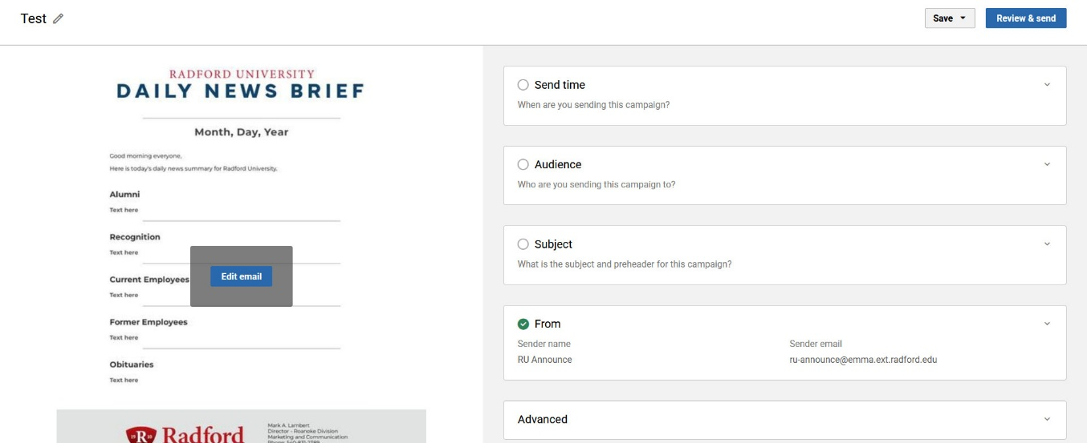
  - On the left is a draft of your e-mail. You can return to editing your e-mail by clicking on the blue Edit email button.
  - To send yourself a test, click on Send time to choose whether you’d like to send it now or schedule it for later.
  - Click on Audience to choose the people who will receive your e-mail. In the Recipients drop down menu, you’ll see the prepopulated segments of groups we can send to at the moment. If you have questions about these groups, contact the Radford University IT Department.
  - Click on Subject to enter the subject of your e-mail.
  - Click on From to change the sender to Radford University or your department name. Always leave the sender e-mail box the same.
  - Click on the blue Review & send button in the upper right hand corner.
  - A final pop-up box will appear with your send details as a final check before sending. Be sure to check all of the details very carefully before sending.
  - When ready, click on Send campaign.

Seeing information on recently sent campaigns
- It will take a few minutes for your e-mail to send to your recipients. Once it has sent, however, you will be able to see valuable real-time information about your campaign in Emma. Here’s how:
  - Go to the Emma homepage.
  - There are thumbnail screenshots on that page of all of the campaigns you have sent.
  - Click on a thumbnail to see information about that campaign.
  - At the top will be information about the open rate (how many recipients opened the e-mail), how many recipients clicked on anything in your e-mail, how successful the delivery rate was (how many of the recipients you meant it to go to actually received it), the bounce rate (how many of the e-mails were returned to Emma as Undeliverable) and the opt-out rate (howe many recipients blocked the e-mail and didn’t receive it).
  - In addition, if you scroll down, you’ll what is called a “heat map” of your e-mail. There are green circles on this map showing where recipients clicked. You can hover over the circles to see how many people clicked on that link.
  - In the left-hand column, you’ll be able to see what percentage of users viewed it on a desktop computer vs. those who viewed it on a mobile device.
  - And, there will be a breakdown of which e-mail software recipients used to view your e-mail.
  - All of this is valuable information to determine how successful your e-mail and messaging was.

If you have issues or if there are people that said they did not get the e-mail, please have them submit a ticket via ITOneStop.

