Degree | Accrediting Body | Current Assessment Cycle
Communication Sciences and Disorders: M.A./M.S. in Communication Sciences and Disorders with a concentration in speech-language pathology | - Council on Academic Accreditation of the American Speech-Language Hearing Association (CAA)  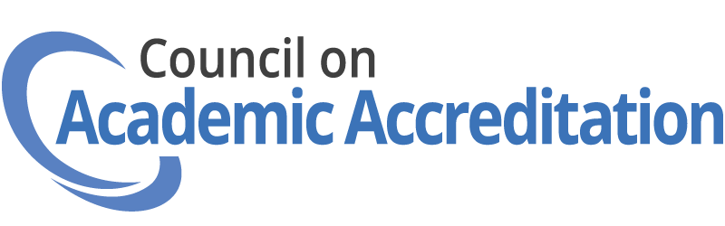 | 2024-2034
Emergency Services: B.S. in Emergency Services | - Committee on Accreditation of Educational Programs for the Emergency Medical Services Professions (CoAEMSP)  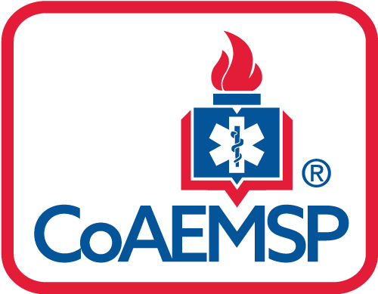  - Commission on Accreditation of Allied Health Education Programs (CAAHEP)  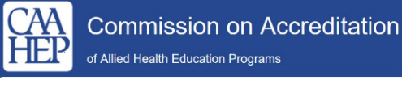 | 2022-2027
Occupational Therapy: M.O.T. in Occupational Therapy | - Accreditation Council for Occupational Therapy Education (ACOTE) of the American Occupational Therapy Association (AOTA)   | 2018-2027/2028
Physical Therapy: D.P.T. in Physical Therapy | - Commission on Accreditation in Physical Therapy Education (CAPTE)  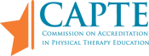 | 2019-2029
Physician Assistant: M.S. Physician Assistant | - Accreditation Review Commission on Education for the Physician Assistant (ARC-PA)   | 2025-2033
Respiratory Therapy: B.S. in Respiratory Therapy | - Committee on Accreditation for Respiratory Care (CoARC)  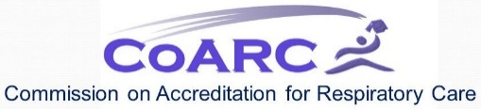 | 2016-2026
Social Work: B.S.W. in Social Work | 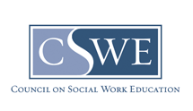  - Council on Social Work Education (CSWE) | 2022-2030
Social Work: M.S.W. in Social Work | - Council on Social Work Education (CSWE) | 2022-2030

