Degree | Accrediting Body | Current Assessment Cycle
Art: B.A., B.S., B.F.A., M.F.A in Art | - National Association of Schools of Art and Design (NASAD)   | 2022-2028
Dance: B.A., B.F.A. in Dance, B.S. in Dance Education with K-12 Teaching Licensure | 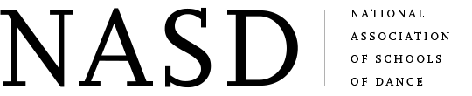  - National Associations of Schools of Dance (NASD) | 2023-2028
Design: B.S., B.F.A. in Design | - National Association of Schools of Art and Design (NASAD) | 2022-2028
Interior Design: B.F.A. in Interior Design | - Council for Interior Design Accreditation (CIDA)  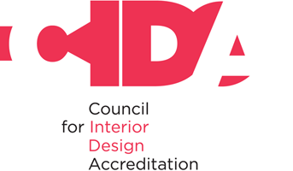  - National Association of Schools of Art and Design (NASAD) | 2020-2026  2022-2028
Music: B.A./B.S. in Music | 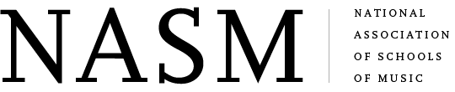  - National Association of Schools of Music (NASM) | 2024-2034
Music: B.M. in Music | - National Association of Schools of Music (NASM) | 2024-2034
Music: M.A., M.S. in Music | - National Association of Schools of Music (NASM) | 2024-2034
Theatre: B.A./B.S. in Theatre | 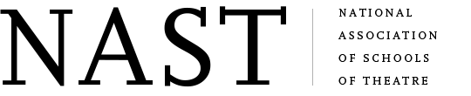  - National Association of Schools of Theatre (NAST) | 2013-2027

