Degree | Accrediting Body | Current Assessment Cycle
Psychology: Ed.S. in School Psychology | - National Association of School Psychologists (NASP)  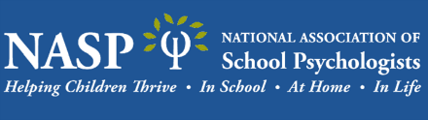  - Council for the Accreditation of Educator Preparation (CAEP)  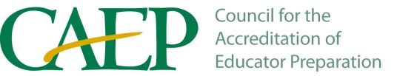 | 2025-2030  2020-2026

