Degree | Accrediting Body | Current Assessment Cycle
Computer Science: B.S. in Computer Science and Technology with a concentration in Computer Science | 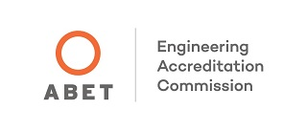  Accreditation Board for Engineering and Technology | 2022-2028
Medical Laboratory Science: B.S. in Medical Laboratory Science | National Accrediting Agency for Clinical Laboratory Sciences (NAACLS)  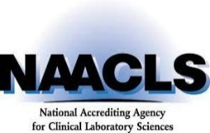 | 2024-2029

