

Possible Syllabus Elements
(Rev 08/6/2026)

Please think of this document as a kind of buffet of options for your syllabus. We recognize that this is long. We encourage faculty members to consider breaking this information up into several sections of their START HERE modules in D2L, such as “course requirements,” “course policies,” “wellness and safety policies,” etc., which might make this information more accessible to students.

Contents

Basic Course Information 2
Instructor Information 2
Course Description 2
Course Prerequisite(s) or Co-requisite(s) 2
Program Outcomes 2
Course Learning Objectives 2
Course Learning Objective 2
Associated Program Outcomes 2
Required Texts/Materials 2
Method(s) of Evaluation 2
Example Grading Scale 3
Sample Attendance Policies for Face-to-Face and Online Courses 3
Sample Language for Face-to-Face Classes #1: 4
Sample Illness Policies by Course Format 5
Sample Language for Face-to-Face Classes: 5
Sample Language for Online Synchronous Classes: 5
Sample Language for Online Asynchronous Classes: 5
Digital Devices Policy 5
Artificial Intelligence (AI) Use 6
Practice 1: Prohibited 7
Practice 2: Prescribed 7
Practice 3: Open 7
Late Work Policy 7
Workload Expectations 8
Academic Honor Code 9
Zoom technology 9
Zoom engagement 9
D2L 10
Computer Access 10
Inclusion and Community Statements 10
Our Inclusive Learning Environment: 10
Our Brave Learning Environment: 11
Land Acknowledgement 11
Student Support Services 11
Center for Accessibility Services 11
Harvey Center for Learning and Writing 12
Highlander Success Center 12
Peer Academic Coaching 12
Technology Support 12
The Technology Assistance Center provides a number of options for students to find 12
Counseling 12
Key Dates 13
Topical Course Outline: Important Note: The outline below gives you a brief overview of the topics and due dates for each week/module/unit. 13

Basic Course Information

Course name and number:
Semester:
Number of Credits:
Meeting Time:
Modality (F2F, Online, Hybrid):

Instructor Information

Include information on how to reach the instructor outside of class. Explain how office/visiting hours will be conducted. Will they be in person? Virtually? Both? How will students schedule appointments?

You might also consider adding a brief paragraph detailing your teaching and research/creative interests (perhaps even your hobbies) in case students are interested in your other courses or approaching you about research, career questions, etc.

Course Description

Include in your description why you think students will find this course engaging and relevant.

Course Prerequisite(s) or Co-requisite(s)

Program Outcomes
If the course offering is mapped to program outcomes, consider including the program outcomes addressed by the course.

Course Learning Objectives
Course Learning Objective | Associated Program Outcomes

Required Texts/Materials
If any.

Method(s) of Evaluation
Explain clearly what students will do, what is expected of them, and how the work will be assessed, including how final grades are determined. Hint: Some faculty members find it useful to provide a summary of graded items in this section. A pie chart showing the percentage of the final grade each assignment or group of assignments is worth is a useful visual for students.

Example Grading Scale

Total Percentage Points | Letter Grade
90 to 100 | A
80 to <90 | B
70 to <80 | C
60 to <70 | D
Less than 60 | F

Example Grade Pie Chart for a CHEM111 course:

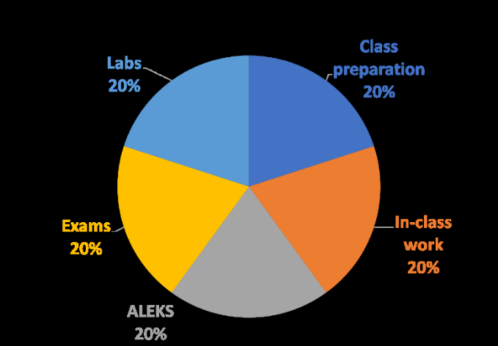

Sample Attendance Policies for Face-to-Face and Online Courses

Syllabus language is a primary way that faculty communicate expectations around participation and attendance, and faculty should address engagement expectations in their syllabi for students who may not be able to attend class face-to-face due to health concerns or emergencies. The sample language below is meant as a guide and can be adapted. The sample language is not required. Keep in mind that language that is welcoming and motivating may aid in students’ sense of belonging and their potential for success.

Faculty members should consider several things to assist learners when developing syllabus language related to attendance and participation. When applicable, faculty members should communicate how to access online portions of the class. Additionally, faculty members should plan to work with the Center for Accessibility Services (CAS) when students need accommodation for the online environment due to accessibility needs. (Please see sample CAS syllabus statement.) Your attendance and participation policies should include the following information:
- Under what circumstances are absences excused if faculty have an attendance policy, and the consequences of unexcused absences.
- The circumstances under which alternatives will be made for students who are unable to attend the course for an extended period (this could include synchronous zoom sessions, recordings, alternative asynchronous assignments, etc.)
- When possible, students should notify the faculty of absences in advance
- Expectations and means for how students would make up missed coursework
- Expectations are clear for synchronous and asynchronous online participation, as well as face to face participation

These attendance policies should be communicated to students in the first week of classes and should be in the course syllabus.

Sample Language for Face-to-Face Classes #1:
I’m glad you are here! My expectation is that you will attend all class meetings and be prepared and engaged when you are here. This class works best when all of us are involved in discussing and learning the material, and it’s more interesting and meaningful for all of us when that occurs. I do understand that there are times when something may prevent your attendance: people get sick, emergencies occur, you are participating in an athletic or university event that requires travel, and so on. If an emergency or similar unforeseen event occurs, please contact me via email as soon as it’s feasible and we’ll talk about making up any assignments you might have missed. If you are traveling to, or participating in, a university event, please let me know ahead of time so we can make arrangements regarding the course material and assignments. This policy does not apply to non-emergencies like sleeping through class or just blowing off class. Keeping the lines of communication open will help us be better able to handle situations that may arise.

If you are experiencing symptoms of communicable illness and believe you have been exposed, please consider getting tested before you return to class. Most pharmacies have daily testing options, and Radford University offers testing as follows:

  - Radford Campus Student Health Center: Call 540-831-5111 to schedule an appointment for testing or other health services.
  - If you are a Radford University Carilion Student (Roanoke Campus) you will need to contact Radford University Carilion. Radford University Carilion offers a remote nurse navigator line for students at RUC's Roanoke campus.
    - RUC Roanoke Campus Nurse Navigator Line
Monday - Friday, 9 a.m. - 1 p.m.*
540-795-3273
This remote service is currently for RUC's Roanoke campus students only.
*Hours will vary during school breaks, including summer break.

Sample Illness Policies by Course Format

Sample Language for Face-to-Face Classes:
Your learning and growth, as well as your contributions to our class, require your attendance and engagement. If you need to miss for an athletic or other University-sanctioned event, please let me know (with University documentation) in advance so you can keep up with class work on time. If you are ill or have another emergency, please contact me via e-mail as soon as you can to discuss making up work. If exceptional circumstances (such as COVID-19 or a family emergency) require you to miss classes for multiple days, please contact me as soon as you can to discuss how to make progress in the course remotely. For COVID-19 or other illnesses, I would appreciate documentation. For non-emergency situations, missing more than three classes will result in a lower grade for attendance and engagement.

Sample Language for Online Synchronous Classes:
Be online on time! This course will meet via Zoom. Our discussions, team work, and other in-class activities are essential to your learning in this class, and I value your contributions. I take attendance at the beginning of each class session. It is imperative that you are present and on time for all classes and are prepared to participate fully in all activities and discussions. If you must be absent due to documented illness, please contact me and consult our schedule in D2L to keep up to date on class progress. Because you are a valuable member of our learning community it is important that you provide prior notice of when you will be absent or late to class. It is my expectation that you will email or call me ahead of time to let me know. Otherwise, I look forward to Zooming with you!

Sample Language for Online Asynchronous Classes:
Welcome to our learning community! This class will be completed asynchronously. While we will have a few scheduled class, team, and individual meetings, our primary “classroom” will be on D2L. It is essential that you check out announcements and our class schedule every day on D2L so that you can access class material, complete assignments on time, contribute your insights to our online discussions and teams, and otherwise be a strong presence in our online community. If you are unable to keep up with class due to extended illness or another emergency that prevents you from making progress, please reach out to me immediately. Otherwise, I am looking forward to “seeing” you on D2L. Learning is a community endeavor and your presence is important to us!

Digital Devices Policy

This is a sample digital devices policy.
This class is far more interesting and a better learning environment when everyone is engaged, listening, and contributing. We are all challenged (myself included) by the ways in which our digital devices—laptops, tablets, and phones—can steal our attention away from our immediate surroundings. In this class we will have a device policy that is designed to support your attention to one another and to the course material. I have developed this policy for three reasons:
- A significant body of research demonstrates that when students engage in off-task behavior on their devices, it hurts the learning of peers sitting near them. In one study, students who were not using a device in a class lecture but were seated within view of a peer with a device, performed 17 % worse on an exam based on that lecture material than students who were not within view of someone else’s device. (Glass, A.L. & Kang, M. (2019). Dividing attention in the classroom reduces exam performance. Educational Psychology, 39(3), 395-408.)
- This class depends upon everyone’s active engagement. Your ideas about the material in this class will become richer when they are articulated and engaged in dialogue with the ideas of your peers. If you are focused on your device, instead of our work, you are missing an opportunity to learn and depriving your classmates of the opportunity to learn from you. Your attention contributes to all of our learning.
- Finally, since so much of the course depends upon discussion, I want to make sure that we all show respect for one another by listening to each other. We all have all likely had the experience of trying to speak with someone who was focused on their phone and feeling hurt by their lack of attention to us. In this class, I want us to respect everyone’s voices by being present and listening to each other.

To achieve those objectives, the digital device policy is as follows:
- You may use laptops to read course material and take notes as needed. If you use a laptop, close any tabs that are not related to the course. Remember, off-task behaviors can hurt the learning of your classmates.
- You may have your phone out on your desk but keep it facedown and silent, so you are not continually seeing and hearing new notifications that steal away your attention and the attention of your classmates. Those notifications have been engineered to hijack your attention and can hurt your and your classmates’ learning.
- There will be times in class when I want everyone to put their devices away and focus on some activity. In those activities, we will all be device free.
- Finally, to show everyone that we are listening respectfully to one another, please remove any AirPods, earbuds, or headphones from your ears at the start of class.

If anyone has an accommodation that would make any of these policy items challenging in any way, please let me know by email, so I can modify the policy accordingly. If you have any other concerns about the policy, please let me know. I want to ensure that this policy supports our work while meeting your needs as a student.

Artificial Intelligence (AI) Use

Statements may be used in part or in their entirety. Faculty are encouraged to specify practices in their syllabus that are congruent with their course learning outcomes. The following texts are adapted from the University of Delaware and shared using a Creative Commons license.

Considerations for Using Artificial Intelligence in this course. You should note that all large language models still tend to make up incorrect facts and fake citations. Artificial intelligence models tend to produce inaccurate outputs, and image generation models can occasionally come up with highly offensive products. You will be responsible for any inaccurate, biased, offensive, or otherwise unethical content you submit regardless of whether it originally comes from you or an AI tool. This syllabus includes the course assignments and the degree to which you may use artificial intelligence to complete the corresponding assignment.

Practice 1: Prohibited
All work submitted during this course must be your own. Contributions from anyone or anything else, including AI sources, must be properly quoted and cited every time they are used. Failure to do so violates the institution's academic misconduct/integrity policy. Any allegations of academic misconduct will be adjudicated using the process outlined in the Standards of Student Conduct.

Practice 2: Prescribed
There are situations and contexts within this course where students will be permitted to use generative AI tools to explore how they can be used to complete course work. Any student work submitted using generative AI tools should clearly indicate what work is the student’s original work and what part is generated by AI. Outside of those instances that are permitted, students are discouraged from using generative AI tools to generate content (text, video, audio, images) that will end up in any student work (assignments, activities, responses, etc.) that is used to assess student learning.
Any allegations of academic misconduct will be adjudicated using the process outlined in the Standards of Student Conduct.

Practice 3: Open
Within this class, you are welcome to use artificial intelligence tools in a totally unrestricted fashion, for any purpose. Any student work submitted using generative AI tools should clearly indicate what work is the student’s original work and what part is generated by AI.

A more extensive guide to AI syllabus statements, including assignment level guidance is available HERE.

Late Work Policy

You should include your policy around late work and stick to it (with flexibility in extreme circumstances). If you are looking for ways to build flexibility into the system, you might consider a “menu” approach (students turn in at least 10 out of 15 assignments, for example) or a scaffolded approach where students turn in small parts of a larger assignment over time (culminating in a due date). For flexibility, consider a policy such as an Oops! Token where students can use an Oops! Token to extend a deadline for a certain amount of time on one or more assignments with no questions asked.

Sample Oops Token Late Work Policy
Sometimes stuff happens and you miss a deadline. If that happens, you may use an Oops Token to turn in work late without penalty. You will have two Oops Tokens. The reason it’s late doesn’t matter. This is what you have to do:
- Tell me you’re using one of your Oops Tokens;
- Turn in the work within three days of the original due date (so Due Date, Late Day 1, Late Day 2, Late Day 3);
- If the work is turned in by 11:59 PM on Late Day 3, then the work will be graded as if it were turned in on time with no penalty and no questions asked.
- If the work is not turned in by 11:59 PM on Late Day 3, then the work will not be accepted, and you will receive a zero on that work.
Use the Oops Tokens wisely. If you use them on an assignment that has multiple parts, it’s possible to jam yourself up for other due dates. And once you use them, they’re gone. Late work without an Oops Token will not be accepted.

Workload Expectations

You may wish to include a graphic or other description of how many hours students can expect to be working on course activities each week.

Sample workload graphic for a CHEM111 course: 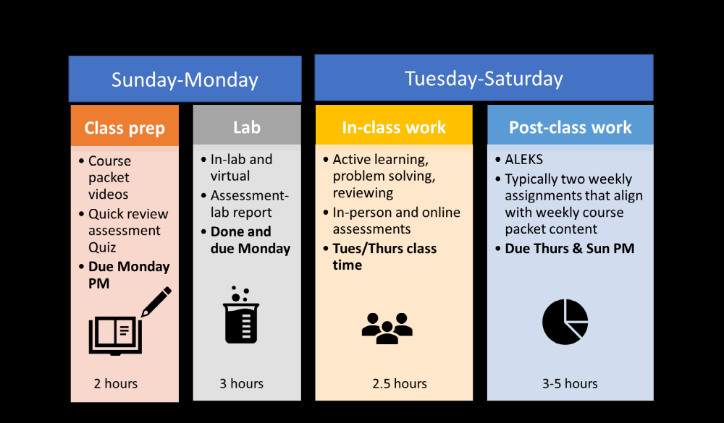

Academic Honor Code
All students are responsible for following the Honor Pledge and for looking up further information as needed:
I shall uphold the values and ideals of Radford University by engaging in responsible behavior and striving always to be accountable for my actions while holding myself and others to the highest moral and ethical standards of academic integrity and good citizenship as defined in the Standards of Student Conduct.

Turning in AI-generated work as your own is considered plagiarism and is a violation of the Honor Pledge.

Zoom technology
This class may use Zoom which is a web and video conferencing tool. Please be sure you have Zoom installed and are familiar with using the tool. Below are tips for participating in a Zoom session.
• Join the meeting early and test speaker, microphone, and camera settings
• Keep speakers away from microphones to avoid feedback
• Use a headset with microphone if possible
• Don’t join a meeting from multiple devices
Additional Zoom resources can be found at www.radford.edu/zoom (open zoom drop-down near top of page).

Zoom engagement
Whether we meet in person, on Zoom, or in other digital formats, we are in a professional community. As professionals, we are expected to:
• show up on time
• be prepared for our collective work
• be appropriately attired
• try to limit distractions in our individual workplaces

As members of a community, please consider the effects of your actions on your colleagues, just as you would in a physical classroom:
• keep your video on if possible
• mute yourself when not speaking
• focus your attention on the speaker

Please let me know if you are having difficulties interacting in class via Zoom, and if there are reasons you can’t follow the above guidelines.

D2L

The links below provide general help for the most common student D2L questions. You may wish to include course specific guidance. For example, if you use online discussions extensively (and in a specific way) consider providing additional guidance to students.
- How to use D2L (Videos)
- 24/7 Technical support portal

Computer Access

Radford University/Radford University Carilion provide campus computer labs for your use. If students need to access laptops, the Connected Communities office offers a “laptop loaner” program for students at no cost. Access the laptop loaner application form here.

Inclusion and Community Statements

You may wish to include a short statement on your syllabus and/or D2L site about your desire to create a space for learning that includes diverse identities and perspectives.

Our Inclusive Learning Environment:
Ensuring that all students from diverse backgrounds and learning abilities are able to contribute, learn, grow, and succeed in this course is my highest priority. As colleagues, we will each commit to showing respect to individuals, to working together to create a learning environment that fosters a sense of belonging and inclusion to all members, and to understanding that our differences are strengths. I commit to offering learning materials and activities that express and are respectful of diversity, and in which all students can see themselves in our field. Your suggestions are encouraged and appreciated.

Our Brave Learning Environment:
Our class is a brave and inclusive space in which we will explore all kinds of perspectives aimed at identifying and analyzing the problems of our time. We will study both the causes of and solutions to ethical issues, and we will often disagree with each other. That’s how great ideas are born and workable solutions designed! I will facilitate our difficult discussions, but I am counting on the class as a community to help us structure mutually meaningful conversations while ensuring that everyone feels included and honored as colleagues sharing the same goals of becoming better humans and creating more equitable and healthy societies and systems. Disagreement should be thoughtful and respectful, and criticism of another’s view should be coupled with evident and empathetic care for the person who holds it. Please think of all our various learning environments, whether on campus, on Zoom, in D2L discussions, or even on social media, as our classroom and community, and consider your actions and words appropriately.

Land Acknowledgement
(with thanks to Professor David Beach for sharing this example)

In the spirit of truth and reconciliation, we acknowledge the Tutelo/Moneton people, as well as other Indigenous peoples, whose land on which Radford University now resides. We recognize their historical and ongoing connection to this land, this water, and this air. We do this to pay respect to the Tutelo/Moneton Nations, and to their elders, past, present, and emerging. We hope to inspire greater curiosity among non-Native peoples about the land on which they live, to halt the erasure of Indigenous history, and to encourage support of Indigenous communities both locally and globally. We acknowledge this because for too long Native people have been unseen and unrecognized — including being denied access to our institutions of higher education.

If you are unfamiliar with land acknowledgements, this is an excellent resource: A Guide to Indigenous Land Acknowledgment - Native Governance Center

Student Support Services

Delete services that won’t apply, e.g., RUC services for RU Radford Campus students, and vice-versa. You may also refer students to your course’s D2L homepage. There is a box on the right side with links to Student Help/ Support Resources.]

Center for Accessibility Services
If you are a student with special needs or circumstances, I invite you to contact me early in the course so appropriate supports and scheduling can be addressed. Students seeking academic accommodations under the Americans with Disabilities Act must register with Radford University’s Center for Accessibility Services (CAS). The policies regarding students with disabilities may be found at http://www.radford.edu/content/cas/home.html. You may also contact the CAS office at: 540-831-6350; ASL users 540-922-1176; cas@radford.edu.

Harvey Center for Learning and Writing
The Harvey Center for Learning and Writing offers tutoring, writing support, study spaces, and resources—for free! They are located on the 4th floor of McConnell library. Contact them at harvey@radford.edu or stop by.

Highlander Success Center
The Highlander Success Center (HSC) is located on the Radford campus in Young Hall and at Radford University Carilion on the 5th floor of Carilion Roanoke Community Hospital. The HSC includes academic advising, career and talent development consulting and planning, student connections programming, and retention initiatives to support students throughout their academic journey at Radford University and Radford University Carilion. Regardless of the location, the HSC staff offer one-on-one support, group workshops, and training sessions on everything students need to support their academic and professional success. See the HSC webpage for more on its services.

Peer Academic Coaching
Peer Academic Coaches (PACs) are academically successful students who serve as coaches for undergraduate students in the Highlander Success Center (HSC Radford and Roanoke). These students are experts in academic strategies, success skills, and resources on campus to support you to develop strong learning practices and assist in navigating our campus experience. Book appointments with a PAC through Starfish, or visit the 4th Floor of Young Hall in Radford or 5th Floor of Carilion Community Hospital in Roanoke.

Technology Support

The Technology Assistance Center provides a number of options for students to find
answers to common questions and request assistance.
- Find common answers or submit an online support request: www.radford.edu/itonestop
- Phone Support: (540) 831-7500; Monday - Thursday 8 a.m. – Midnight, Friday 8 a.m. - 5 p.m.
- Walk-in Support (Appointment Recommended); Walker Hall Room 153; Monday through Friday 8 a.m. – 4:45 p.m.

Counseling
Student Counseling Services (SCS) offers individual, group, and couples counseling sessions to students. Students located on main campus can contact SCS by visiting this website: https://www.radford.edu/student-counseling/index.html.

Radford University Carilion (RUC) students seeking counseling services and support can find resources at https://www.radford.edu/student-counseling/radford-university-at-carilion.html.

Key Dates

You may wish to provide a link to the current Academic Calendar, or copy and paste the current academic calendar from the web page (Academic Calendar) to your syllabus.

Topical Course Outline: Important Note: The outline below gives you a brief overview of the topics and due dates for each week/module/unit.
Week of | Learning Objective and Content | Assignments / Due Dates

