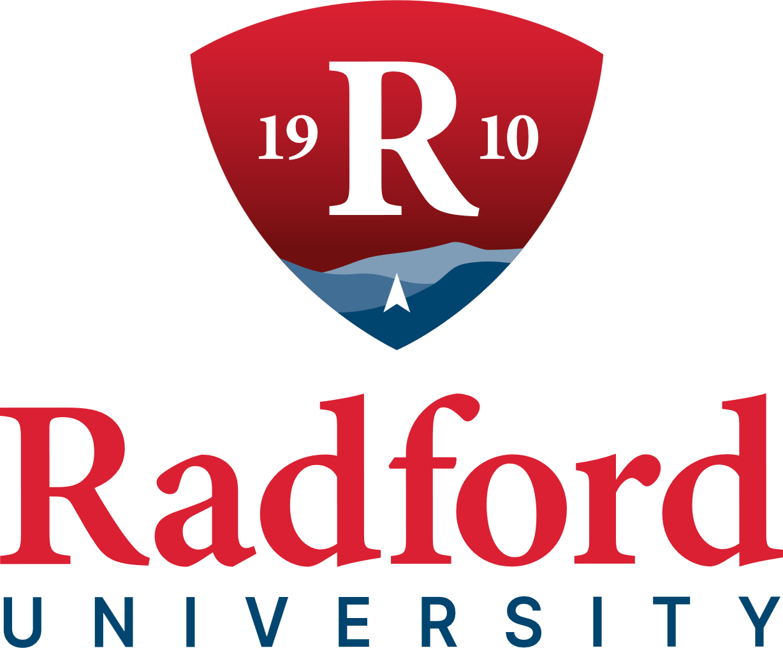

External Engagement Committee
1:00 pm
September 17, 2026
Kyle Hall, Room 340
Radford, VA

DRAFT MINUTES
COMMITTEE MEMBERS PRESENT
Ms. Betsy Beamer, Chair
Ms. Mary Anne Holbrook, Vice Chair
Ms. Nancy Rice

COMMITTEE MEMBERS ABSENT
Ms. Stacey Brayboy
Mr. William C. Davis

BOARD MEMBERS PRESENT
Mr. Dale S. Ardizzone, Rector
Mrs. Jennifer Wishon Gilbert, Vice Rector
Ms. Joann Craig
Ms. Callie M. Dalton
Ms. Jeanne P. Fishwick
Ms. Betty Jo Foster
Mr. Tyler W. Lester
Mr. Christopher Settle
Mr. David A. Smith
Mr. Jonathan D. Sweet

OTHERS PRESENT
Dr. Dannette Beane, Vice President for Enrollment Management and Strategic Communications
Mr. Ryan Bowyer, Chief of Staff
Ms. Lisa Ghidotti, Assistant Vice President for Government Relations and Strategic Initiatives
Ms. Nichole Hair, Director of Economic Development and Community Engagement
Dr. Robert Hoover, Vice President for Finance and Administration
Dr. Angela Joyner, Vice President for Economic Development and Corporate Education
Ms. Susan Richardson, University Counsel
Dr. Bethany Usher, Provost and Senior Vice President for Academic Affairs
Ms. Penny Helms White, Vice President for Advancement and Alumni Relations

CALL TO ORDER
Ms. Betsy Beamer, Chair, formally called the External Engagement Committee meeting to order at 1:11 pm, Kyle Hall in Room 340, Radford, Va.

APPROVAL OF AGENDA
Ms. Betsy Beamer, Chair, asked for a motion to approve the September 17, 2026, agenda, as published. Ms. Mary Anne Holbrook, Vice Chair, made the motion and Ms. Nancy Rice, seconded, and the motion carried unanimously.

APPROVAL OF MINUTES
Ms. Betsy Beamer, Chair, asked for a motion to approve the minutes of the June 4, 2026, meeting of the External Engagement Committee meeting, as published. Mrs. Jennifer Wishon Gilbert, Vice Rector, made the motion. Ms. Mary Anne Holbrook, Vice Chair, seconded, and the motion carried unanimously.

ECONOMIC DEVELOPMENT AND CORPORATE EDUCATION
The Board received an update from Dr. Angela Joyner, Vice President for Economic Development and Corporate Education on Economic Development and Corporate Education’s recent activities and accomplishments, organized around the organization’s mission of bringing people together, connecting individuals and communities to opportunity, and serving as a trusted regional partner.

Roots in the Region
Dr. Angela Joyner, Vice President for Economic and Development and Corporate Education gave an update on the progress on the division's Strategic Plan for 2026 through 2031, noting that the narrative behind the plan is only meaningful if supported by data. As of August 13, the plan comprises 55 total actions. Of these, 22% have been achieved and are complete. Fifty-five percent are on track and actively progressing. The remaining 24% have not yet started.
Dr. Joyner explained the reasoning behind the not-yet-started actions. The majority of this group is staffed, scoped, and sequenced to launch in conjunction with the onboarding of the new Continuing Education Director. The remaining actions in this category are intentionally sequenced to allow time for securing resources and establishing partnerships, positioning the division to deliver with excellence once underway.
Dr. Joyner provided an overview of the Joint Commission, describing it as the body where Radford University and City of Radford leadership convene at the same table, in the same room, working from a shared strategic framework. The Joint Commission has produced its first annual impact report highlighting the progress achieved through this collaboration.
Dr. Joyner reported on the annual Economic Development and Business Leaders Luncheon, "Shaping Tomorrow: Building a Regional Economy Together," which convened Virginia's Secretary of Commerce and Trade, the Executive Director of Onward NRV, and the Executive Director of the New River Regional Commission. Dr. Joyner noted that having a sitting Secretary of Commerce and Trade at the table signals how seriously the Commonwealth views Radford's role in the region's economic strategy.
Ms. Nichole Hair, Director of Economic Development and Community Engagement, shared highlights from the highly successful inaugural AdventureWorks Summit, held September 8-9. More than 100 attendees participated in curated outdoor experiences, including ziplining and a historic boat ride on Claytor Lake, as well as panel discussions focused on the outdoor economy.

The third annual Community Fest was a tremendous success and served as a testament to the City of Radford and Radford University’s continued commitment to connecting with and engaging the community.

Next Generation
Radford University expanded its participation in the Onward NRV Experience and Summer Internship Leadership Program, placing Radford students in regional workforce roles and providing opportunities for experiential learning and engagement throughout the region. More than 40% of participating interns stated they have intentions to remain in the region post-graduation.

The People Behind the Mission
Dr. Angela Joyner introduced three new team members: Cor Blevins, Program Coordinator, Dr. Jeanne Symanoskie, Director for Continuing Education, and Dr. Ben Kramer, Assistant Program Coordinator. All three have joined the organization and are expected to expand Economic Development and Corporate Education team’s capacity to serve the region.

UNIVERSITY ADVANCEMENT AND ALUMNI RELATIONS
Ms. Penny Helms White, Vice President of Advancement and Alumni Relations gave the board updates from the Advancement and Alumni Relations division highlighting the theme “Turning Connection into Impact.” She emphasized how sustained engagement with alumni and friends can develop into meaningful partnerships and philanthropic support for the University.
An example of this impact was Mr. Chris Shockley, a 1992 graduate of Radford University, whose involvement with Radford University included attending alumni events, providing philanthropic support, serving on the Davis College Advisory Board, and hosting a Business and Industry Leaders meeting. These connections developed into a partnership opportunity with Virginia Credit Union and ultimately led to the establishment of the Virginia Credit Union Financial Success Center.

FY26 Success
Ms. Penny Helms White reported FY26 as a strong year for Advancement and Alumni Relations, with progress in fundraising, stewardship, engagement, and staffing. Highlights included:
- Hosting the Highlander Athletics: The Next Chapter stewardship event.
- Launching a new stewardship plan and athletic cumulative giving societies.
- Recruiting members for the new Athletics Philanthropy Council.
- Launching five new donor societies and holding events to celebrate each society.
- Strengthening the Advancement team through the hiring of an athletic fundraiser, an advancement leadership gift associate, an assistant director of student philanthropy and engagement, and an assistant director of donor relations.
- Training six Radford University Ambassadors as the inaugural class of Tartan Blazers to expand student engagement efforts.
- Completing 30 ThankView campaigns and sending 4,139 videos to constituents.
- Relaunching the Society of 1910 and holding its first induction ceremony.
- Investing in professional development, with 17 team members attending professional development conferences.

The Numbers

The following results were reported for FY26:
- $11.3 million raised.
- 2,764 donors engaged.
- $3.3 million in scholarships awarded.
- 2,498 volunteers engaged.
- $4.5 million raised for Athletics from 1,422 donors.
It was noted that these results represent not only financial support, but also the collective engagement of Radford University alumni, donors, volunteers, and the broader University community.

Opportunities for Improvement

Ms. Penny Helms White also identified areas for continued improvement, including stewardship, analytics, volunteer engagement, technology, and staffing. These areas will be key to becoming more strategic, efficient, and designed to specifically strengthen every stage of the donor cultivation cycle.

FY27 Fundraising Progress
As of the end of August, Advancement had raised $2.5 million in FY27, providing a strong foundation for continued fundraising efforts. Ms. Penny Helms White stated that the division’s priorities remain clear to strengthen donor retention, increase alumni participation, build the major gift pipeline, expand planned giving commitments, and continue to elevate the donor experience.

Highlighted Events
- Virginia Credit Union Financial Success Center Dedication – September 24
- Richmond Chapter Alumni and Friends Golf Tournament – September 18
- RAD Giving Day – September 22–23
- Homecoming – October 22–24
- Gratitude Week – November 5–7
Ms. Penny Helms White concluded her presentation by emphasizing that the work of the Advancement and Alumni Relations team is ultimately about creating opportunities. Every scholarship awarded, every student experience enhanced, every facility improved, and every program strengthened begins with meaningful relationships.
ADJOURNMENT
With no further business to come before the committee, Ms. Betsy Beamer, Chair adjourned the meeting at 2:03 pm.

Respectfully submitted,

Sharon R. Ratcliffe
Executive Assistant to Vice President of Advancement and Alumni Relations

