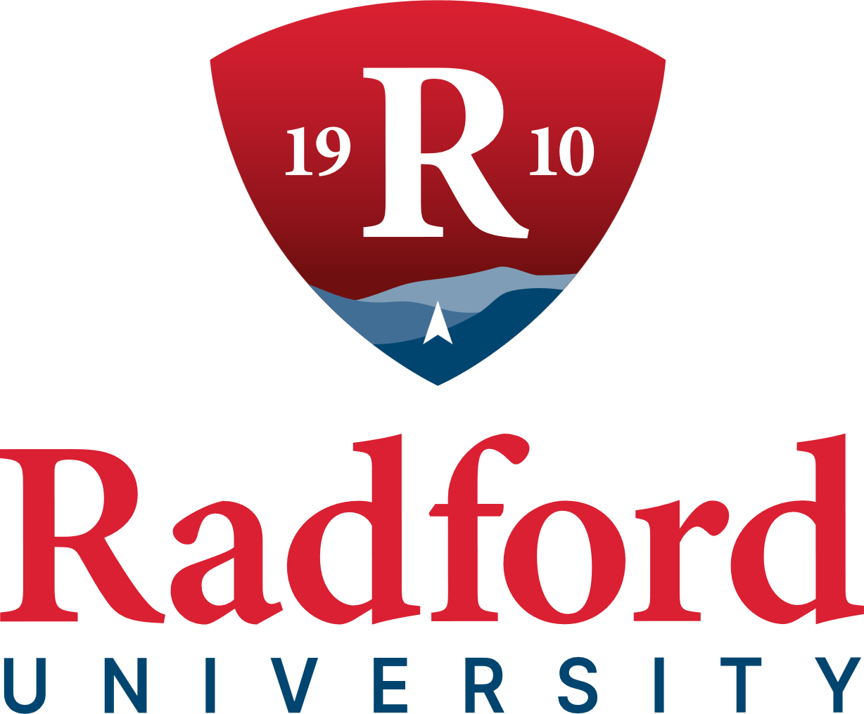

External Engagement Committee
1:00 pm
June 4, 2026
Kyle Hall, Room 340
Radford, VA

DRAFT MINUTES

COMMITTEE MEMBERS PRESENT
Ms. Betsy Beamer, Chair
Mr. George Mendiola Jr., Vice Chair
Mr. Dale S. Ardizzone
Ms. Mary Anne Holbrook
Mr. Chris Settle

BOARD MEMBERS PRESENT

Mr. Tyler W. Lester, Rector (Via Zoom)
Mrs. Jennifer Wishon Gilbert, Vice Rector
Ms. Jeanne S. Armentrout
Dr. Betty Jo Foster
Mr. David A. Smith
Mr. Jonathan D. Sweet

Ms. Callie M. Dalton

Mr. James C. Turk

Mr. William Davis

OTHERS PRESENT
Dr. Dannette Beane, Vice President for Enrollment Management and Strategic Communications
Mr. Ryan Bowyer, Chief of Staff
Ms. Lisa Ghidotti, Assistant Vice President for Government Relations and Strategic Initiatives
Dr. Robert Hoover, Vice President for Finance and Administration
Dr. Angela Joyner, Vice President for Economic Development and Corporate Education
Ms. Susan Richardson, University Counsel
Ms. Laura Turk, Executive Director of Alumni Relations
Dr. Bethany Usher, Provost and Senior Vice President for Academic Affairs
Ms. Penny Helms White, Vice President for Advancement and Alumni Relations

CALL TO ORDER
Ms. Betsy Beamer, Chair, formally called the External Engagement Committee meeting to order at 1:01 pm, Kyle Hall in Room 340, Radford, Va.

APPROVAL OF AGENDA
Ms. Betsy Beamer, Chair, asked for a motion to approve the June 4, 2026, agenda, as published. Mr. William Davis made the motion and George Mendiola, Jr., Vice Chair, seconded, and the motion carried unanimously.

APPROVAL OF MINUTES
Ms. Betsy Beamer, Chair, asked for a motion to approve the minutes of the March 19, 2026, meeting of the External Engagement Committee meeting, as published. George Mendiola, Jr., made the motion. Mrs. Jennifer Wishon Gilbert, Vice Rector, seconded, and the motion carried unanimously.

ECONOMIC DEVELOPMENT AND CORPORATE EDUCATION
Dr. Angela Joyner delivered a presentation entitled Mission in Motion, a narrative-based divisional update organized around the core commitments of convening community members, expanding access to opportunities, and strengthening the university’s role as a trusted regional partner. The presentation addressed six strategic focus areas.

Strategic Partnerships & Community Engagement
Dr. Joyner announced that a series of regional community town halls is scheduled for August–October, designed to identify local needs and cultivate trust through direct engagement. The Joint Commission Impact Report functions as an integrated strategic roadmap, documenting measurable outcomes and mutual accountability. A five-year strategic plan for Downtown Radford is currently in development, addressing economic vitality, policy, design, and tourism. The story of BT’s Restaurant – a 40-year community institution now operated by RU alumni – was highlighted as a compelling illustration of this work in practice.

Dr. Joyner announced that AdventureWorks! is being held September 8–9 and will bring together leaders from local government, small business, higher education, and tourism and advance regional economic development priorities.

Student Success & Experiential Learning
Two team members, multimedia assistant Desi Yopp and intern Kyleigh Mills (BBA/Management), were spotlighted as the division’s commitment to developing talent from within its own community.

Academic Achievement & Workforce Education
Dr. Svetlana Filitreau represented the division on the CCI Southwest Virginia Panel at UVA Wise. The division was honored with the 2026 CCI Impact Award.

Communications
The Exchange, a new comprehensive communications platform and newsletter, launched May 1st. It is designed to deliver transparent, timely information to both on-and off-campus stakeholders.

Culture of Care
The presentation concluded with an emphasis on team development and organizational culture. Recent graduates Jonas, Mady and Mary – each a former student employee of the division – were recognized as living examples of the university’s mission carried out.

Board Engagement
Dr. Joyner invited Board members to consider where they can best amplify impact, identify partners or resources that could strengthen existing initiatives, and share their vision for what Mission in Motion should look like as the division enters its third year.

UNIVERSITY ADVANCEMENT AND ALUMNI RELATIONS
Ms. Penny Helms White, Vice President of Advancement and Alumni Relations reported that FY26 fundraising totaled $9.8 million dollars as of the end of April, reflecting strong donor relationships and dedication of the Advancement and Alumni Relations team.
As athletics remains a key area of growth in advancement efforts. A search is underway for a Director of Advancement and Revenue Generation for Athletics. In addition, an Athletic Philanthropy Council is being formed to strengthen volunteer engagement and increase support for Radford Athletics, including attendance and event participation. A pilot initiative is also underway to reconnect former student-athletes with current scholar-athletes. Stewardship and retention also continue to be a priority focus. In April, members of the Red Brick and New River Societies were recognized for their ongoing generosity and commitment to the university.
Planned giving efforts continue to expand, including features in the Spring 2026 university magazine highlighting three donor legacy stories. New spring and fall planned giving postcards are being distributed for outreach, and planning is underway for a retiree engagement event scheduled for August 12.
Efforts to strengthen engagement with students and recent graduates continue to build momentum. The Senior Block Party engaged more than 400 students, while over 500 exit interviews were conducted to support post-graduation outreach. The second annual Tartan Toast, held in conjunction with a Highlander Baseball game, with 150 graduating seniors in attendance. A new Assistant Director of Student Philanthropy and Engagement has joined the team to further support early engagement strategies.
Advancement and Alumni Relations led commencement planning, marking the beginning of graduates’ lifelong connection to Radford University. Eugene Naughton served as keynote speaker, and a surprise video message from Dolly Parton generated significant national attention, enhancing the university’s visibility.
Laura Turk, Executive Director of Alumni Relations, provided an update on Volunteer Pathways to Philanthropy. It was reported that Radford engages 3,832 volunteers, including 2,498 unique individuals serving in 221 roles across eight decades and thirty-five states. Volunteer engagement continues to strengthen alumni connection, advocacy, and philanthropic support, with personal referrals playing a key role in expanding participation and fundraising opportunities.
A video featuring student Shannon Herrity ’27 was shared, reminding us that the impact of the work we do across Advancement and Alumni Relations reminding us why this work matters.
In closing, Ms. Penny Helms White shared several upcoming events including Highlander Athletics: The Next Chapter, the National Capital Region Alumni and Friends Golf Tournament on June 25, Radford Night at Nationals Park on August 7, the Radford University Retiree Event on August 12, and Radford Night at Party in Elmwood Park on August 13.

ADJOURNMENT
With no further business to come before the committee, Ms. Betsy Beamer, Chair adjourned the meeting at 2:12 pm.

Respectfully submitted,

